IB Biology I - Unit 1: Cells – Topic 1 (topic 2 in old book)
- Microscopes
  - Compound Light Microscopes
    - Magnify objects 2000 times
  - Electron Microscopes
    - Uses electrons instead of light to magnify structure up to 500,000 times
        - SEM = Scanning Electron Microscope
          - Scans the surfaces of cells to learn 3-D shapes
        - TEM = Transmission Electron Microscopes
          - Studies the structure contained within a cell
  - Advantages to Light Microscope
    - Images viewed in color
    - Larger field of view & inexpensive
    - Samples more easily prepared
    - Living materials can be viewed
  - Advantages to Electron Microscope
    - Higher magnification (but specimens must be dead)
    - Greater resolution
  - Magnification
    - Size of image/ by size of specimen
    - Example: You measure the length of the image to be 100 mm. If the actual length (using the scale bar) of the image is 10 µm, what is the magnification of the image you are looking at?
      - Magnification = ??????
    - Relative sizes using appropriate SI units
      - Molecules (1 nm) (Smallest)
      - Cell membrane thickness (10 nm)
      - Viruses (100 nm)
      - Bacteria (1 µm)
      - Organelles (up to 10 µm)
      - Most cells ( up to 100 µm) (Largest)
- Cell Types
  - Prokaryotes
    - Cell lacking membrane bound organelles (no compartmentalization)
    - Smallest cell = about 1 µm to 10 µm
    - First on Earth
    - Contain DNA that is not separated from the rest of the cell
      - DNA is 1 single, long, continuous, circular thread
      - Nucleoid = region where DNA is located
      - Plasmids = small circular DNA molecules that are not connected to the main bacterial DNA (replicate independently)
    - Contains ribosomes – protein synthesis
    - Metabolic activities
      - photosynthesis – creating glucose from light
      - nitrogen fixation – using atmospheric N
      - fermentation – creating glucose with no oxygen

    - Exterior structures
      - Flagella – long hair like structures used for movement
      - Pili – short hair like structures used for attachment (sexual reproduction – transfer DNA to another bacteria cell)
      - Capsule – used for protection and made of a polysaccharide
      - Cell Wall – maintains shape & protects and contains a carbohydrate-protein complex called peptidoglycan
      - Plasma membrane – controls movement of materials in and out of the cell
    - Reproduces sexually or asexually (binary fission)
    - Ex: bacteria and blue-green algae
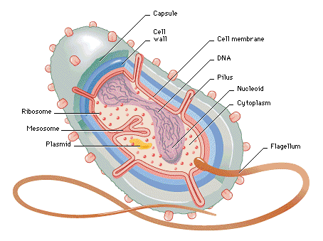
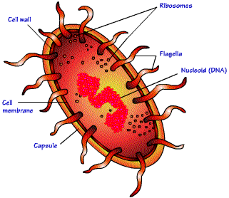
  - Eukaryotes
    - Contains membrane bound organelles and is compartmentalized
    - Can be multicellular or unicellular
    - Size = eukaryotic cells are one to one hundred times bigger than prokaryotic cells = up to 100 µm
    - Contains DNA that is segregated from the rest of the cell
    - Ex: animal cells and plant cells
  - Organelles – discrete structure within an eukaryotic cell with a specific function
    - Homeostasis — maintaining the cells internal environment (pH & temp) otherwise the cell could cease to function or malfunction
    - Organelles = membrane bound structures in Eukaryotic cells

    - Common structures and organelles
      - Plasma membrane
      - Cell Wall (plant only)
      - Nucleus
      - Nucleolus
      - DNA
      - Cytoplasm
      - Centrioles/Centrosomes (mostly animal only)
      - Microtubules
      - Endoplasmic Reticulum (ER) (rough & smooth)
      - Ribosomes
      - Golgi Complex
      - Lysosomes (animal only)
      - Vacuole
      - Mitochondria
      - Chloroplasts (plant only)
      - Cilia & Flagella
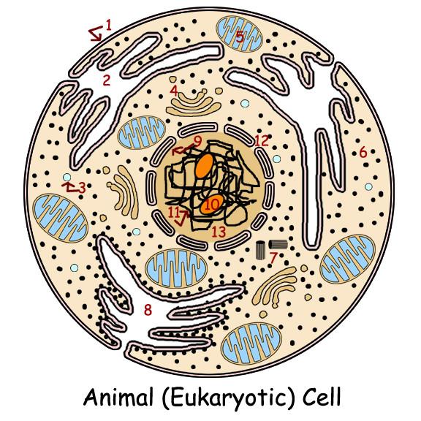
  - Compare Prokaryotes & Eukaryotes
  - Compare Plant cells & Animal cells
- Cells
  - Organization
    - Atoms = ________ –> molecules = ________-> organelles = ________-> cells = _________-> tissues = ________-> organs = ________-> organ systems = ________-> organism = ________
  - Cell differentiation – cells becoming specialized
    - Results in the expression of certain specific genes in the DNA become active but not others
    - Some cells reduce or lose the ability to reproduce
      - Example: nerves & muscle cells
    - Some cells retain the ability to reproduce but still produce the same cell type as the parent
      - Example: skin cells (epithelial cells)
    - Emergent properties = the whole is more than the sum of its parts (interactions between all the different parts of a particular biological unit)
      - A whole organism is capable of carrying out more functions than the sum of the functions each cell is specialized in
  - Stem cells – cells that retain their ability to divide and differentiate into various cell types
    - Plants = meristematic tissue (roots & stems)
    - Animals = bone marrow, cord blood or embryonic (pluripotent cells or iPS)

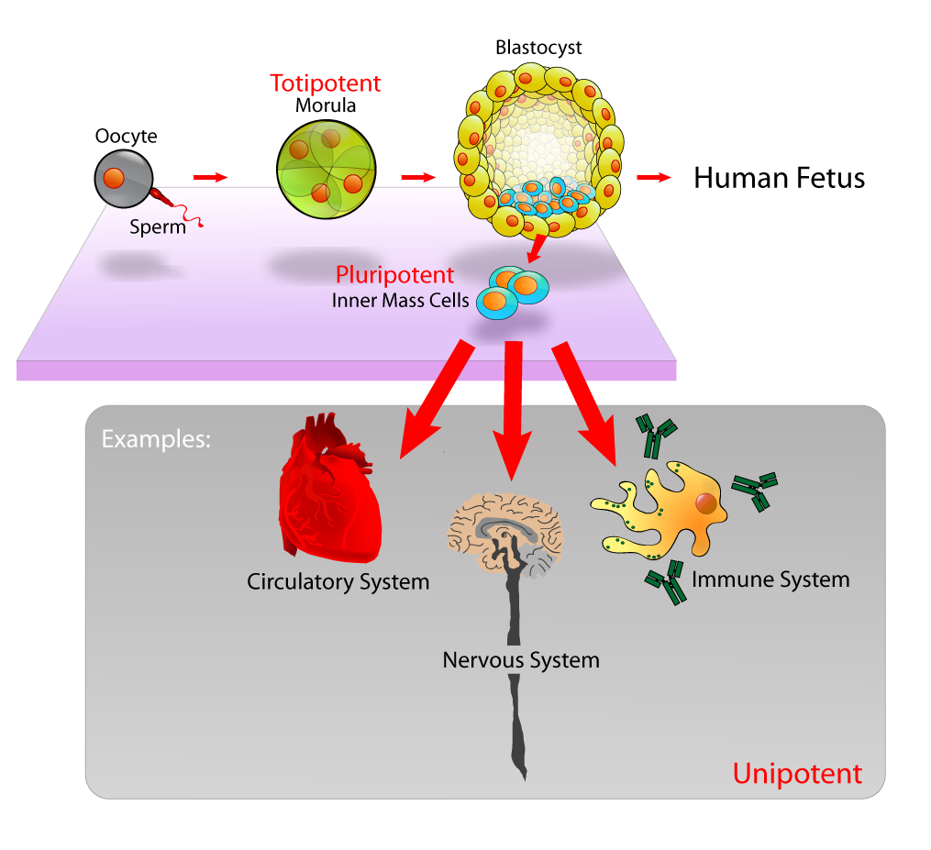
      - Controversial
      - Alternative: Use adult stem cells (adipose & wisdom teeth)
    - Used in therapeutic cloning
      - treatment of diseases such as Parkinson’s & Alzheimer’s
      - tissue-specific stems cells to treat leukemia (replacing making bone marrow cells)
      - Stargardt’s disease = defect in the processing of vitamin A (vitamin A is essential for the light-sensitive cells in the retina to function)
        - Loses central vision then peripheral vision then blindness
        - Stem cells are used to regenerate photoreceptors in the retina
  - Conditions of living things
    - Reproduce
    - Respond to stimulus (homeostasis)
    - Grow and develop
    - Made of cells
    - Take in and utilize energy (metabolism & excretion)
  - Cytology – the study of all aspects of a cell
  - Cell Theory
        - All organisms are composed of one or more cells
        - The cell is the basic unit of organization
        - All cells come from pre-existing cells
  - History to support Cell Theory
    - Robert Hooke - British scientist who first described cells in 1665 (studied cork of trees) with a self-built microscope
    - Antonie van Leeuwenhoek – observed first living cells and called them “animalcules” (little animals)
    - Matthias Schleiden – stated plants are independent separate beings called cells in 1838 (one year later about animals)
    - Louis Pasteur – demonstrated living organisms would not spontaneously reappear
      - Sterilized (boiled) nutrient broth
      - Sterile broth was then placed in three flasks
        - Open flask
        - Sealed flask
        - Sealed flask with distilled water
      - Cells re-established after exposure to pre-existing cells
    - Missing component of Cell Theory: Origin of cells
      - No evidence that new cells arise from non-living material today (called spontaneous generation)
      - Pasteur’s experiment – only the flask which was open and exposed had presence of bacteria
        - Proves spontaneous generation wrong
      - Current explanation = Endosymbiotic Theory (1981)
        - About 2 billion years ago a bacterial cell took up residence inside a eukaryotic cell or larger bacterial cell
        - The eukaryotic cell or larger bacterial cell acted as a predator bringing the bacterial cell inside
        - The eukaryotic cell or larger bacterial cell and the bacterial cell formed a symbiotic relationship (both organism lived in contact with one another)
        - The bacterial cell then went through a series of changes to ultimately becomes a mitochondria & provides ATP to the larger cell
      - Evidence of Endosymbiotic theory = mitochondria & chloroplast
        - Are about the size of most bacteria
        - Divide by fission like bacteria
        - Divide independently of the host cell
        - Have their own ribosomes (to produce proteins)
        - Have their own DNA (closely resembles prokaryote DNA & not eukaryote DNA)
        - Have two membranes on their exterior (consistent with an engulfing process)
      - Evidence of Endosymbiotic theory = DNA
        - DNA provides a code to make proteins (64 different words to make proteins)
        - This code is universal and has the same meaning in nearly all organisms on Earth
  - Limiting Cell Size =
    - Surface area to volume ratio =effectively limits the size of a cell
      - Function of volume = rate of heat & waste production & rate of resource consumption
      - Function of surface area = controls what materials move in & out of the cell
      - As cells increase in size the surface area increases at a much slower rate than the volume
      - The greater the volume the smaller the ratio of surface area to volume
      - This ratio limits how large cells can be (ratio begins decrease = 6 then to 3 then to 1.5 then to 1)
      - Conclusion: bigger cells have less surface area to bring in materials and get rid of waste therefore cells are limited in the size they can reach & still carry out life functions
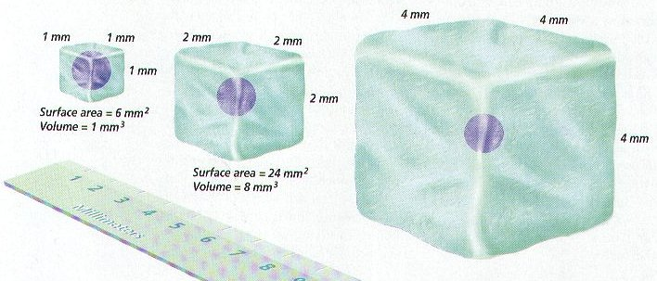
- Membrane Structures
  - Bacteria – cell wall of peptidoglycan
  - Fungi – cell wall of chitin
  - Yeast – cell wall of glucan & mannan
  - Algae & Plants – cell wall of cellulose
  - Animals – no cell wall but a Plasma membrane of glycoproteins
    - Extracellular matrix (ECM) – contains collagen fibers & glycoproteins (carbohydrates & proteins)
      - Forms fibre-like sturctures that anchor the matrix to the plasma membrane
      - Functions - strengthens the plasma membrane, allows attachment between adjacent cells and allows cell-to-cell interactions
- Plasma Membrane
    - 8 nm thick
    - Function = Selective permeability
      - allows some substances to cross it more easily than others
      - cells may have a solution different from the surrounding solution while still permitting uptake of nutrients & eliminating wastes
      - discriminates in its chemical exchanges with its environment
    - Discovery
      - Davson-Danielli model – proposed (1935) a lipid bilayer model suggesting it was covered on both sides by a thin layer of globular proteins “protein sandwich model”
      - Singer & Nicolson – proposed (1972) that proteins are inserted into the phospholipid bilayer and no not form a layer on the phospholipid bilayer surfaces but formed a mosaic floating in a fluid layer of phospholipids
        - Reason #1 – not all membranes are identical or symmetrical as the first model implied
        - Reason #2 – Membranes with different functions also have different composition & different structure
        - Reason #3 – a protein layer is not likely because it is largely non-polar & would not interface with water
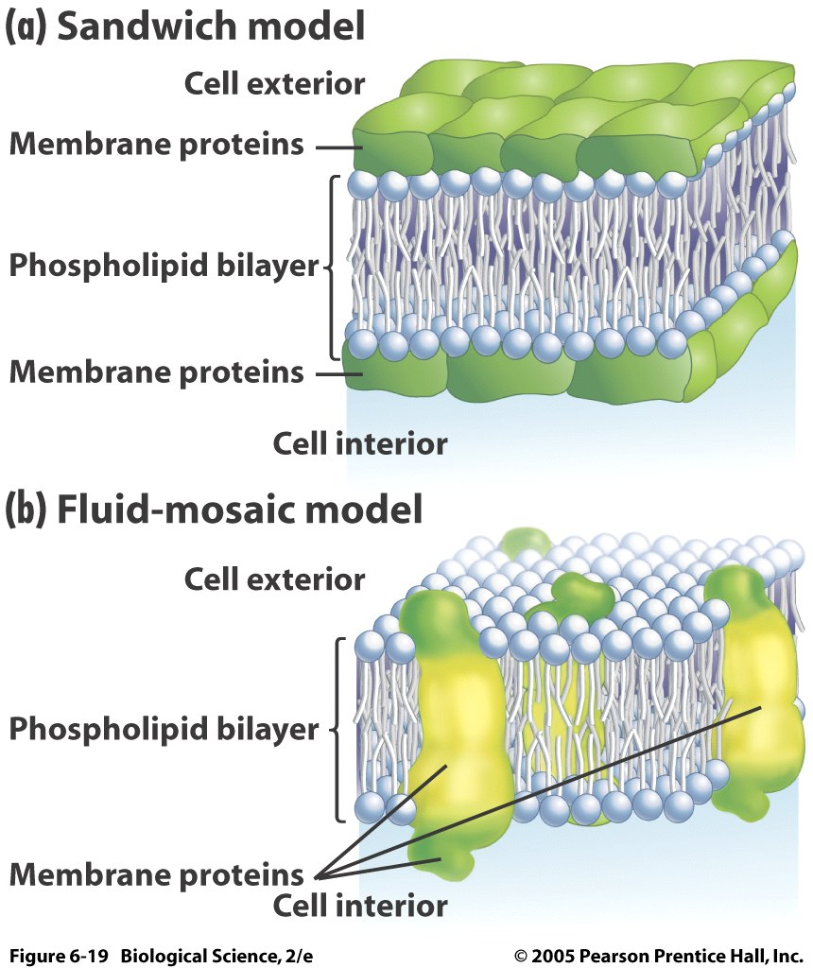
    - Fluid Mosaic Model
      - Double layer of phospholipids – bilayer
        - Phospholipids contains =
          - three-carbon compound called glycerol
            - two of the glycerol carbons have fatty acids (non-polar & not water soluble)
            - the third glycerol carbon is attached to a polar alcohol with a bond to a phosphate group (polar & water soluble)
        - Phospholipids are amphipathic molecules (contain both properties)
          - hydrophilic region = phosphorylated alcohol side (polar)
          - hydrophobic region (nonpolar)
          - both properties form a stable bilayer in an aqueous environment
      - contains mostly lipids & proteins (some carbohydrates) embedded in or attached
        - cholesterol – in hydrophobic region in animal cells & creates the fluidity and stability (which changes with temp)
        - glycolipids – carbohydrate covalently bonded to lipid to provide energy & serve as markers for cellular recognition
        - glycoproteins – carbohydrate covalently bonded to peripheral proteins for cell-to-cell interactions/communication and immune responses (can be attached inside or outside of cell membrane)
    - Membrane Proteins – creates the mosaic effect
      - Integral protein
        - Show an amphipathic character
        - Penetrate the hydrophobic core of the lipid bilayer & is attached permanently to membrane
        - Control the entry and removal of specific molecules from the cell (mostly polar molecules, particularly ions & carbohydrates)
      - Peripheral proteins
        - Do not protrude into the middle hydrophobic region but remain bound to the surface of the membrane
        - Are attached to the outside of the membrane (sometimes temporarily) & attach to an integral protein
      - Functions of proteins
        - Hormone-binding sites – these have specific shapes exposed to the exterior that fit the shape of specific hormones. This attachment causes a change in shape of the protein which results in a message being relayed to the interior of the cell
        - Enzymatic Action – cells have enzymes (interior or exterior) attached that catalyze chemical reactions (metabolic pathways)
        - Cell Adhesion – proteins that can hook together to provide permanent or temporary connections (gap junctions or tight junctions)
        - Cell-to-cell communication – provide an identification label that represents the cells of different species
        - Channels for passive transport – these span the membrane providing passageways for substances to be transported through (moving from high to low concentration)
        - Pumps for active transport – proteins that shuttle a substance form one side of the membrane to another by changing shape (requires ATP/energy)
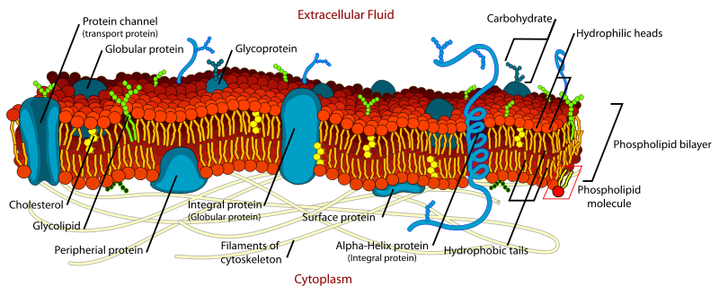
- Cellular Transport of substances
  - Due to a Concentration gradient
    - Difference in concentration across a space
    - Diffusion will continue until there is no concentration gradient = equilibrium
  - Simple Diffusion
    - Movement of particles (other than water) from an higher concentration to an area of lower concentration (due to random movement)
    - Substances move between phospholipid molecules or through proteins that possess channels
    - Example: oxygen and carbon dioxide in and out of cells
  - Osmosis
    - Movement of water across a concentration gradient
    - Water molecules moving from an area of high concentration to an area of low concentration across a partially permeable membrane
    - Only water moves through the membrane using Aquaporins = proteins with specialized channels for water movement
    - A concentration gradient of water that allows the movement to occur is the result of a difference between solute concentrations on either side of a partially permeable membrane
      - Isotonic =
        - concentration of total solutes outside is the same as the concentration of solutes inside the cell
        - Equilibrium occurs = no water movement
      - Hypotonic =
        - High concentration of solutes inside the cell (less water)
        - Low concentration of solutes outside the cell (more water)
        - Osmosis will occur and water will move through the membrane and into the cell
        - Cells will get bigger

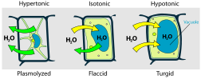

      - Turgor Pressure will occur in a Hypotonic environment
        - Pressure that builds inside a cell as the result of osmosis
        - Makes cell rigid
        - Too much turgor pressure will make animal cells burst
        - In plants it supports the cells and the plant itself
      - Hypertonic
        - Low concentration of solutes inside the cell (more water)
        - High concentration of solutes outside the cell (less water)
        - Osmosis will occur to move water out of the cell
        - Cell will shrink
      - Plasmolysis will occur in a hypertonic environment
        - Loss of water resulting in a drop in turgor pressure
        - Can cause cell to wilt
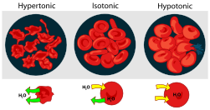
- Transport Systems
  - Passive transport
    - Net movement of substances across a plasma membrane without energy (ATP)
    - Example: osmosis, diffusion, co-transport & facilitated diffusion
    - Not everything can pass through (Water is most common)
    - Co-transport –simultaneously sending two solutes across the lipid bilayer (passively in a natural direction)
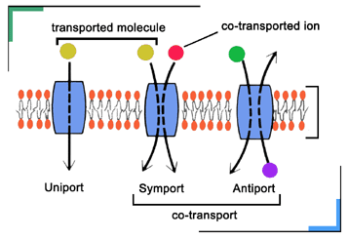
      - Transport proteins - Provide convenient openings and allow needed substances or waste materials to move through the membrane
            - Channel - which allow solutes to cross if they are the correct size and charge
            - Carrier – (non-channel) bind to the solute and lead it through the bilayer
    - Facilitated diffusion
      - diffusion of materials across the plasma membrane through a non-channel proteins carrier (carrier protein)
      - combines with substance to change shape in order to aid in movement (no ATP)
  - Active transport
    - Transport of materials against a concentration gradient and requires energy (ATP)
    - This is how cells can get materials they need to maintain homeostasis
    - Example: Sodium-potassium pump
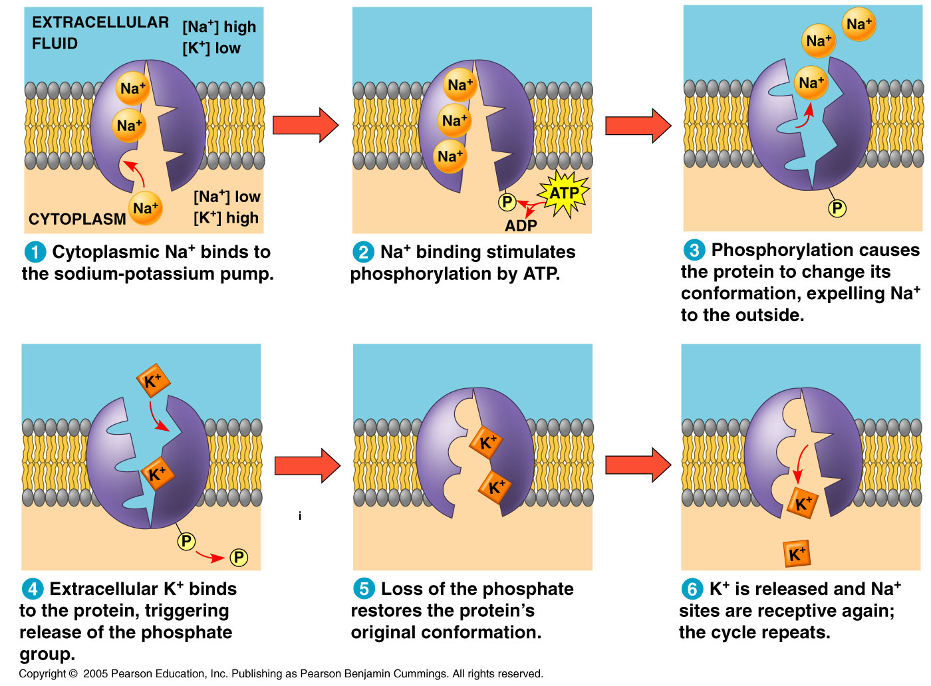
  - Endocytosis
    - A process that allows macromolecules to enter the cell (depends on the fluidity of the membrane)
    - Process where a portion of the plasma membrane is pinched off to enclose macromolecules and enter the inside of the cell
    - The pinching off involves a change in the shape of the membrane and creates a vesicle
    - The ends of the membrane reattach because of the hydrophobic and hydrophilic properties of the phospholipids and the presence of water
      - Phagocytosis = movement of large particles of solid food or whole cells into the cell like white blood cells that fight infection and amoebas
      - Pinocytosis = a form of endocytosis that involves liquid droplets
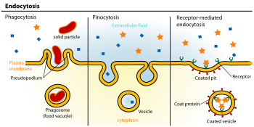
  - Exocytosis =
    - The reverse of endocytosis
    - Used to move waste or substances (proteins) from the interior of the cell to the outside environment
      - Example of exocytosis of proteins
        - Vesicle coming from RER
        - Vesicle entering the cis side of the Golgi apparatus
          - Cis face – receiving side of Golgi
          - Trans face – shipping side of Golgi
        - Cisternae move in a cis-to-trans direction
        - Vesicle leaves the trans side of the Golgi apparatus with modified contents
    - Examples:
          - Pancreas cells produce insulin & secrete it into the bloodstream (to help regulate blood glucose levels)
          - Neurotransmitters are released at the synapse in the nervous system
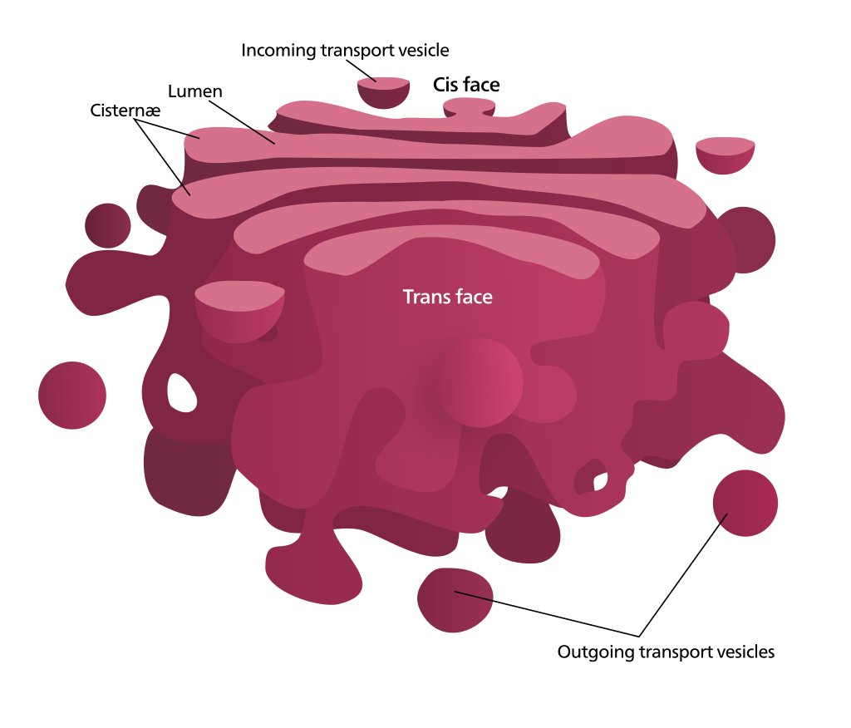

Challenge Question: A girl is getting ready for school. As she is getting ready to put her contacts in, she realizes that she is out of contact solution. Her mother has a bottle of distilled water that she uses for ironing sitting cloths. The girl picks up the bottle and uses the distilled water on her contacts. Her eyes get red and irritated and her contacts pop out. Why does this happen? I do not understand if it is hypertonic or hypotonic.

Answer: It is hypotonic. Her eyes are getting red because water is flowing into her cells and damaging and/or lysing those cells. Ideally contact lens solution is isotonic, i.e., a salt solution (NaCl) with the same osmolarity as is found in her extracellular tissues as well as inside of her cells. The contrasting situation is placing too concentrated a salt solution in your eyes (sea water, for example). In this case the eye's cells are damaged by too much water flowing out of them, into the seawater. With that example the solution (the seawater) is hypertonic. There is too much salt. The underlying mechanism of osmosis is the flow of water from a region of high water concentration to a region of low water concentration. However, the prefixes hyper and hypo refer to the relative salt (solute) concentrations. The hypertonic solution has too much solute (more than the reference solution) while the hypotonic solution has too little solute (less than the reference solution). Finally, I keep track of hyper and hypo by thinking of "hypo"dermic needles. These are employed to deliver stuff to "beneath" the surface of the skin. The term "hypo"tonic, in turn, refers to a solution which has a salt concentration which is "beneath" that of the reference solution, e.g., the inside of a cell.

