HL IB Biology II: Cells - Topic 1 (topic 2 in old book)
- Cells
  - Def: basic unit of life & everything living stems from one or more cells (building blocks)
    - Biological membrane that contains biological chemicals
  - Two types
    - Prokaryotic – biochemicals inside the cell are free & not packaged “before nucleus”
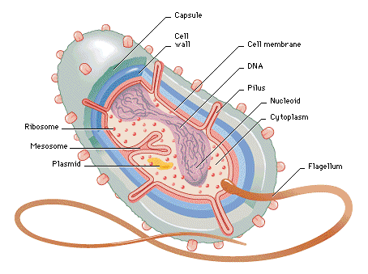
      - ex: bacteria & cyanobacteria (blue-green algae)- 1st living organism on earth
      - metabolic activity including fermentation, photosynthesis and nitrogen fixation
      - Coacervates - is a tiny spherical droplet which maintains an internal environment different from the external environment. These can grow, shrink, and split due to semi-permeable membrane – contains phospholipid bilayer, RNA, & proteins on the inside
        - first theory of abiogenesis (origin of life)
    - Eukaryotic – “true nucleus” organelles are the packages
  - Organism Organization
    - organization of life = atoms→ molecules → organelles → cells → tissues → tissue systems → organs→ organ systems → organisms
      - Tissue - An integrated group of cells that share structure and are adapted to perform a similar function.
      - Organ- A combination of two or more tissues which function as an integrated unit, performing one or more specific functions.
      - Organ system - A group of organs that specialize in a certain function together.
    - Relative sizes using appropriate SI units
      - Molecules (1 nm) (Smallest)
      - Cell membrane thickness (10 nm)
      - Viruses (100 nm)
      - Bacteria (1 µm)
      - Organelles (up to 10 µm)
      - Most cells ( up to 100 µm) (Largest)
        - Drawings should show cells and cell ultrastructure.
        - Include: A scale bar: |------| = 1 µm
        - Magnification: ×250
        - To calculate -- magnification = Measured Size of Diagram ÷ Actual Size of Object
        - Example: If magnification is 5x and length is 60mm
          - 60 mm /5 = 12mm
          - 12mm x 1000 µm = 12000 µm
  - Cell differentiation – cells becoming specialized
    - Results in the expression of certain specific genes in the DNA become active but not others
    - Some cells reduce or lose the ability to reproduce
      - Example: nerves & muscle cells
    - Some cells retain the ability to reproduce but still produce the same cell type as the parent
      - Example: skin cells (epithelial cells)
    - Emergent properties = the whole is more than the sum of its parts (interactions between all the different parts of a particular biological unit)
      - A whole organism is capable of carrying out more functions than the sum of the functions each cell is specialized in
  - Stem cells – cells that retain their ability to divide and differentiate into various cell types
    - Plants = meristematic tissue (roots & stems)
    - Animals = bone marrow, cord blood or embryonic (pluripotent cells)
      - Controversial
      - Alternative: Use adult stem cells (adipose & wisdom teeth)
    - Used in therapeutic cloning
      - treatment of diseases such as Parkinson’s & Alzheimer’s
      - tissue-specific stems cells to treat leukemia (replacing making bone marrow cells)
      - Stargardt’s disease = defect in the processing of vitamin A (vitamin A is essential for the light-sensitive cells in the retina to function)
        - Loses central vision then peripheral vision then blindness
        - Stem cells are used to regenerate photoreceptors in the retina
  - Conditions of living things
    - Reproduce
    - Respond to stimulus (homeostasis)
    - Grow and develop
    - Made of cells
    - Take in and utilize energy (metabolism & excretion)
  - Cytology – the study of all aspects of a cell
  - Cell Theory
        - All organisms are composed of one or more cells
        - The cell is the basic unit of organization
        - All cells come for pre-existing cells
  - History to support Cell Theory
    - Robert Hooke - British scientist who first described cells in 1665 (studied cork of trees) with a self-built microscope
    - Antonie van Leeuwenhoek – observed first living cells and called them “animalcules” (little animals)
    - Matthias Schleiden – stated plants are independent separate beings called cells in 1838 (one year later about animals)
    - Louis Pasteur – demonstrated living organisms would not spontaneously reappear
      - Sterilized (boiled) nutrient broth
      - Sterile broth was then placed in three flasks
        - Open flask
        - Sealed flask
        - Sealed flask with distilled water
      - Cells re-established after exposure to pre-existing cells
  - Limiting Cell Size =
    - Surface area to volume ratio =effectively limits the size of a cell
      - Function of volume = rate of heat & waste production & rate of resource consumption
      - Function of surface area = controls what materials move in & out of the cell
      - As cells increase in size the surface area increases at a much slower rate than the volume
      - The greater the volume the smaller the ratio of surface area to volume
      - This ratio limits how large cells can be (ratio begins decrease = 6 then to 3 then to 1.5 then to 1)
      - Conclusion: bigger cells have less surface area to bring in materials and get rid of waste therefore cells are limited in the size they can reach & still carry out life functions
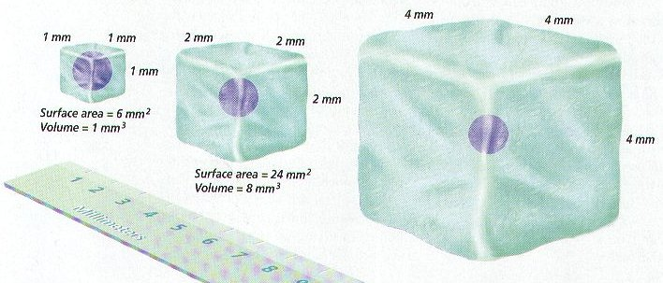

- Membrane Structures
  - Bacteria – cell wall of peptidoglycan
  - Fungi – cell wall of chitin
  - Yeast – cell wall of glucan & mannan
  - Algae & Plants – cell wall of cellulose
  - Animals – no cell wall but a Plasma membrane of glycoproteins
    - Extracellular matrix (ECM) – contains collagen fibers & glycoproteins (carbohydrates & proteins)
      - Forms fibre-like sturctures that anchor the matrix to the plasma membrane
      - Functions - strengthens the plasma membrane, allows attachment between adjacent cells and allows cell-to-cell interactions
  - Plasma Membrane
    - 8 nm thick
    - Function = Selective permeability
      - allows some substances to cross it more easily than others
      - cells may have a solution different from the surrounding solution while still permitting uptake of nutrients & eliminating wastes
      - discriminates in its chemical exchanges with its environment
    - Discovery
      - Davson-Danielli model – proposed (1935) a lipid bilayer model suggesting it was covered on both sides by a thin layer of globular proteins “protein sandwich model”
      - Singer & Nicolson – proposed (1972) that proteins are inserted into the phospholipid bilayer and no not form a layer on the phospholipid bilayer surfaces but formed a mosaic floating in a fluid layer of phospholipids
        - Reason #1 – not all membranes are identical or symmetrical as the first model implied
        - Reason #2 – Membranes with different functions also have different composition & different structure
        - Reason #3 – a protein layer is not likely because it is largely non-polar & would not interface with water
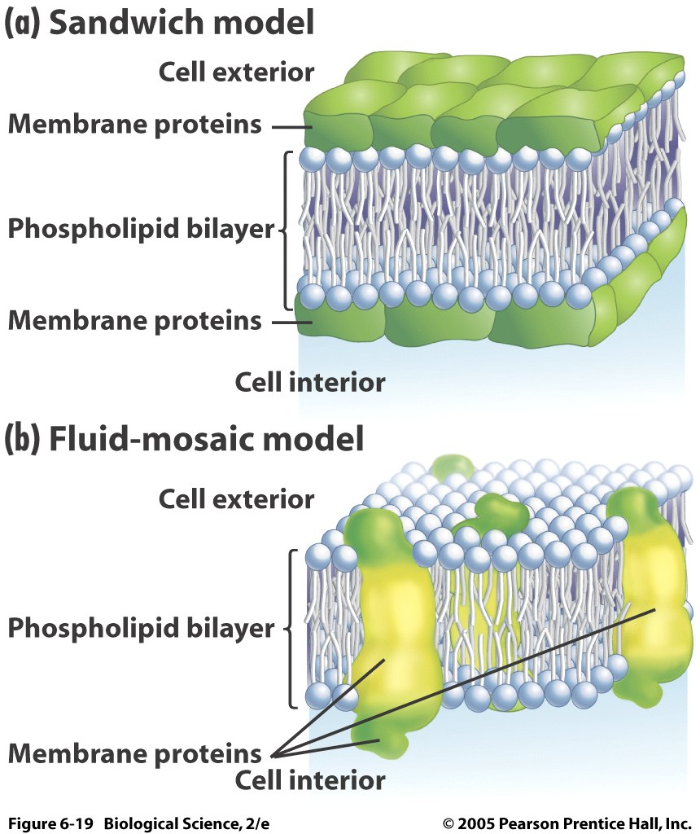
    - Fluid Mosaic Model
      - Double layer of phospholipids – bilayer
        - Phospholipids contains =
          - three-carbon compound called glycerol
            - two of the glycerol carbons have fatty acids (non-polar & not water soluble)
            - the third glycerol carbon is attached to a polar alcohol with a bond to a phosphate group (polar & water soluble)
        - Phospholipids are amphipathic molecules (contain both properties)
          - hydrophilic region = phosphorylated alcohol side (polar)
          - hydrophobic region (nonpolar)
          - both properties form a stable bilayer in an aqueous environment
      - contains mostly lipids & proteins (some carbohydrates) embedded in or attached
        - cholesterol – in hydrophobic region in animal cells & creates the fluidity and stability (which changes with temp)
        - glycolipids – carbohydrate covalently bonded to lipid to provide energy & serve as markers for cellular recognition
        - glycoproteins – carbohydrate covalently bonded to peripheral proteins for cell-to-cell interactions/communication and immune responses (can be attached inside or outside of cell membrane)
    - Membrane Proteins – creates the mosaic effect
      - Integral protein
        - Show an amphipathic character
        - Penetrate the hydrophobic core of the lipid bilayer & is attached permanently to membrane
        - Control the entry and removal of specific molecules from the cell (mostly polar molecules, particularly ions & carbohydrates)
      - Peripheral proteins
        - Do not protrude into the middle hydrophobic region but remain bound to the surface of the membrane
        - Are attached to the outside of the membrane (sometimes temporarily) & attach to an integral protein
      - Functions of proteins
        - Hormone-binding sites – these have specific shapes exposed to the exterior that fit the shape of specific hormones. This attachment causes a change in shape of the protein which results in a message being relayed to the interior of the cell
        - Enzymatic Action – cells have enzymes (interior or exterior) attached that catalyze chemical reactions (metabolic pathways)
        - Cell Adhesion – proteins that can hook together to provide permanent or temporary connections (gap junctions or tight junctions)
        - Cell-to-cell communication – provide an identification label that represents the cells of different species
        - Channels for passive transport – these span the membrane providing passageways for substances to be transported through (moving from high to low concentration)
        - Pumps for active transport – proteins that shuttle a substance form one side of the membrane to another by changing shape (requires ATP/energy)
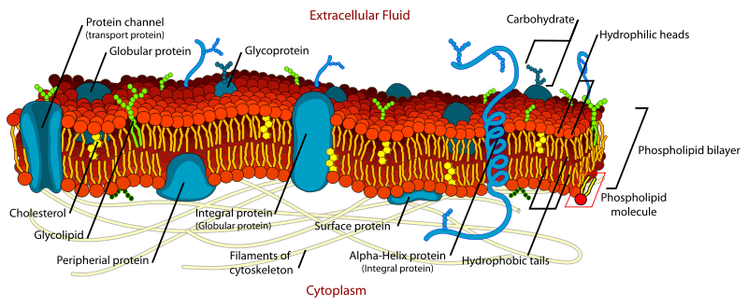
- Eukaryotic Cells (mainly plants)
  - Cell walls – located outside of cell membrane (defining characteristic)
    - Fxn – protection, structural support
    - Structure – interwoven strands of carbohydrates (cellulose, hemicellulose, and pectin), Ca, & proteins
      - Primary vs. Secondary
    - Plasmodesma(ta) –
      - Fxn:
        - holes in cell wall for communication btw cells
        - exchange of materials btw cells
      - Primary pit fields = a bunch plasmadesmata together
    - Middle lamella
      - Structure: pectin layer (carbohydrate) btw the cell wall of two neighboring cells
      - Fxn: acts like the glue btw cells to hold together
    - Intercellular space – space (in corners) btw cells filled with water or gases or storage space for waste
  - Cell membrane (plasma membrane or plasmalemma)
    - Fxn:
      - control center for what goes in & out
      - communication btw cells
    - Structure: phospholipids bilayer
  - Cytoplasm - fluid or cytosol and dissolved materials (minerals & vitamins) and organelles
  - Ribosome -
    - Attached to Rough ER
    - Fxn: protein synthesis
    - Structure: proteins & RNA
  - Cytoskeleton – microtubules & actin filaments
    - Fxn: internal support and movement of things inside the cell
  - Crystals
    - Fxn: storage for protein or waste and protection
    - Structure: proteins or minerals (whatever can solidify or crystallize)
  - Nucleus –
    - Fxns: brains of cell & info storage (DNA)
    - surrounded by a nuclear membrane
    - contains chromosomes
    - contains nucleolus (can have more than one)
      - fxns: makes parts of ribosomes
  - Mitochondria
    - Fxn: aerobic cellular respiration
glucose + O₂ → CO₂ + ATP
    - Structure: has own DNA & ribosomes
    - two membranes surround it (inner & outer)
      - crista: inter membrane (folds)
      - matrix: inner fluid
  - Plastids – unique to green plants and photosynthetic eukaryotes
    - Types & fxns
      - Chloroplast – fxns in photosynthesis =
CO₂ + Water → glucose + O₂ + ATP
          - Pigment: chlorophyll
      - Chromoplast – give plant parts its color (NO photosynthesis)
      - Amyloplast or Leucoplast– store carbohydrates (especially starch)
    - Structure of Chloroplast:
      - Own ribosomes
      - Two membranes
      - Stroma = inner fluid part
      - Thylakoid = internal sac and chlorophyll is part of the thylakoid membrane
      - Granum = stacks of thylakoids (only in chloroplast)
  - Vacuole – largest organelle
    - Fxn:
      - stores oils, water, salts, minerals (not starch)
      - regulates cell size and cell pressure (tonicity)
      - detoxifies
    - Structure: surrounded by tonoplast (single membrane layer)
  - Peroxisomes – smallest organelle
    - Fxns: conversion of stored fats to sucrose – photorespiration
    - Structure: single membrane & crystals inside (protein crystal)
  - Endoplasmic Reticulum
    - Structure: sacs or discs stacked together
    - Types & fxns
      - Rough ER
        - Has ribosomes
        - Fxns: protein synthesis
      - Smooth ER
        - No ribosomes
        - Fxns: making lipids--- phospholipids for membrane & carbohydrates conversion
  - Golgi body or Dictyosome
    - Strucuture:
      - Cisternae = stacks of discs (flat membrane)
      - Vesicles = round membranes
    - Fxns:
      - transport items
      - secretion
      - building cell wall
      - biochemical conversion
        - chemical enters and reproduces it into another product and ships it out
- Origin of Eukaryotic Cells
  - First life on earth = 3.5 billion years
  - Evolutionary events to Eukaryotes (1-2 billion years ago)
    - Formation of Nucleus & ER
      - Supportive Evidence
        - Nucleus has membrane which enclose DNA
        - Nucleus connects to ER
        - Ancient eukaryotes don’t have nucleus (archegoans)
    - Origins of mitochondria and chloroplasts (plastids)
      - Process: Endosymbiotic Theory
        - ancestral cell engulfs mitochondria (independent organism developed from bacteria)
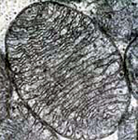
        - mitochondria came in & becomes useful
        - mitochondria makes glucose for the cell so the cell will not dismantle it & keeps it
        - Similar process with chloroplast – developed from bacteria (cyan bacteria) but produces ATP for ancestral cell
      - Supportive evidence:
        - Mitochondria & chloroplasts have two membranes (host cell gave second membrane when entering) & reproduce the same
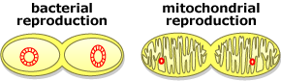
        - Same size as modern prokaryote
        - Own DNA & ribosomes – vestigial but still functional
        - DNA sequences of both are genetically similar to prokaryote DNA
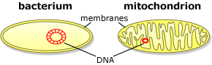
        - Mitochondria evolved 1st because almost all eukaryotes have mitochondria
        - Only a few eukaryotes have chloroplasts
        - Endosymbiosis common in world = when cells are engulfed into another cell & lives together
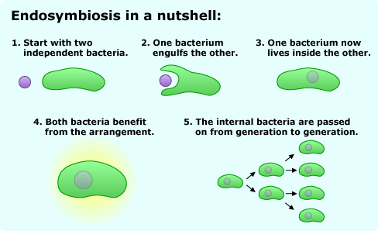
          - Example: nitrogen-fixing bacteria lives in some roots of plants to provide essential nutrients
IB Biology II: Transport Systems
- Cellular Transport of substances
  - Due to a Concentration gradient
    - Difference in concentration across a space
    - Diffusion will continue until there is no concentration gradient = equilibrium
  - Simple Diffusion
    - Movement of particles (other than water) from an higher concentration to an area of lower concentration (due to random movement)
    - Substances move between phospholipid molecules or through proteins that possess channels
    - Example: oxygen and carbon dioxide in and out of cells
  - Osmosis
    - Movement of water across a concentration gradient
    - Water molecules moving from an area of high concentration to an area of low concentration across a partially permeable membrane
    - Only water moves through the membrane using Aquaporins = proteins with specialized channels for water movement
    - A concentration gradient of water that allows the movement to occur is the result of a difference between solute concentrations on either side of a partially permeable membrane
      - Isotonic =
        - concentration of total solutes outside is the same as the concentration of solutes inside the cell
        - Equilibrium occurs = no water movement
      - Hypotonic =
        - High concentration of solutes inside the cell (less water)
        - Low concentration of solutes outside the cell (more water)
        - Osmosis will occur and water will move through the membrane and into the cell
        - Cells will get bigger

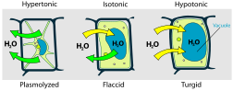

      - Turgor Pressure will occur in a Hypotonic environment
        - Pressure that builds inside a cell as the result of osmosis
        - Makes cell rigid
        - Too much turgor pressure will make animal cells burst
        - In plants it supports the cells and the plant itself
      - Hypertonic
        - Low concentration of solutes inside the cell (more water)
        - High concentration of solutes outside the cell (less water)
        - Osmosis will occur to move water out of the cell
        - Cell will shrink
      - Plasmolysis will occur in a hypertonic environment
        - Loss of water resulting in a drop in turgor pressure
        - Can cause cell to wilt
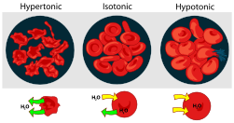
- Transport Systems
  - Passive transport
    - Net movement of substances across a plasma membrane without energy (ATP)
    - Example: osmosis, diffusion, co-transport & facilitated diffusion
    - Not everything can pass through (Water is most common)
    - Co-transport –simultaneously sending two solutes across the lipid bilayer (passively in a natural direction)
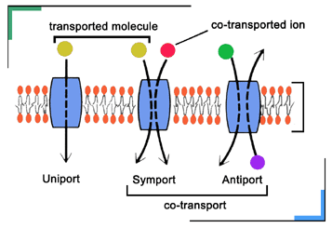
      - Transport proteins - Provide convenient openings and allow needed substances or waste materials to move through the membrane
            - Channel - which allow solutes to cross if they are the correct size and charge
            - Carrier – (non-channel) bind to the solute and lead it through the bilayer
    - Facilitated diffusion
      - diffusion of materials across the plasma membrane through a non-channel proteins carrier (carrier protein)
      - combines with substance to change shape in order to aid in movement (no ATP)
  - Active transport
    - Transport of materials against a concentration gradient and requires energy (ATP)
    - This is how cells can get materials they need to maintain homeostasis
    - Example: Sodium-potassium pump
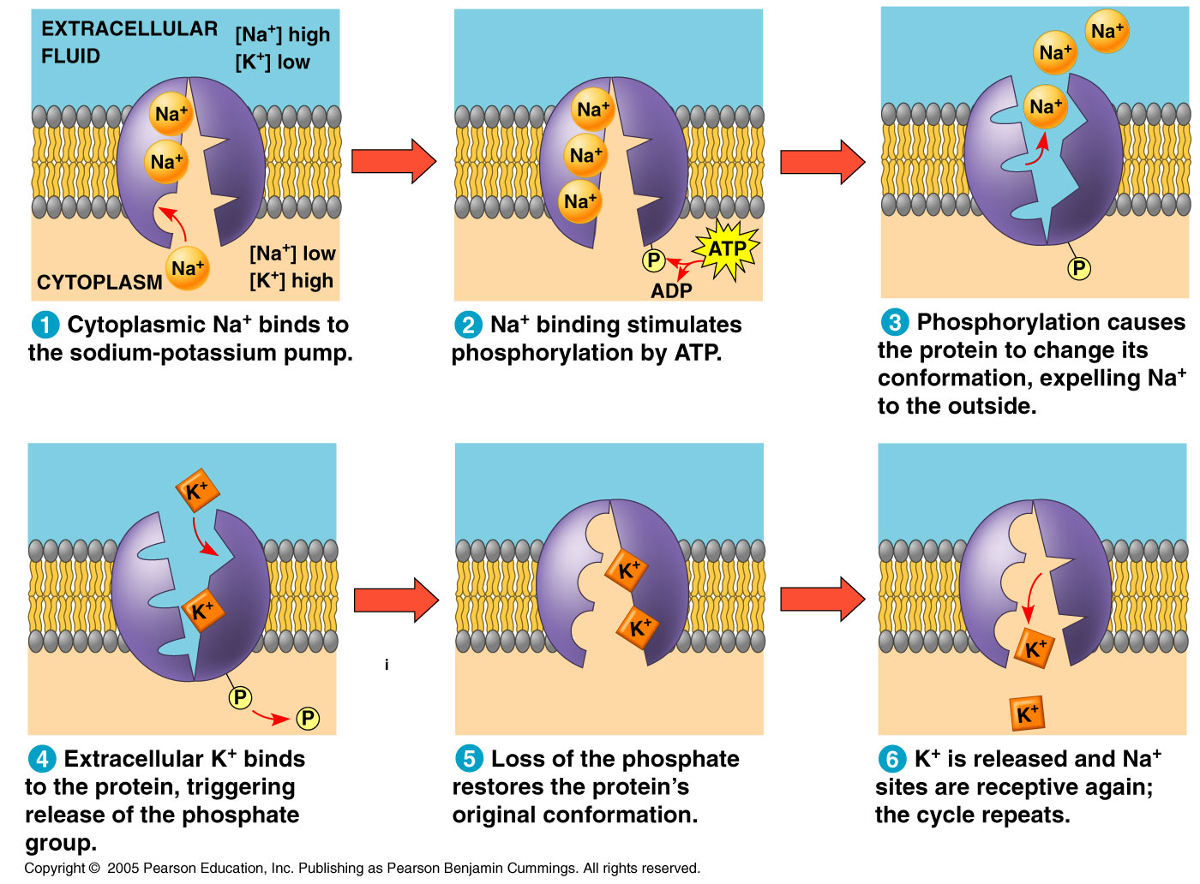
  - Endocytosis
    - A process that allows macromolecules to enter the cell (depends on the fluidity of the membrane)
    - Process where a portion of the plasma membrane is pinched off to enclose macromolecules and enter the inside of the cell
    - The pinching off involves a change in the shape of the membrane and creates a vesicle
    - The ends of the membrane reattach because of the hydrophobic and hydrophilic properties of the phospholipids and the presence of water
      - Phagocytosis = movement of large particles of solid food or whole cells into the cell like white blood cells that fight infection and amoebas
      - Pinocytosis = a form of endocytosis that involves liquid droplets
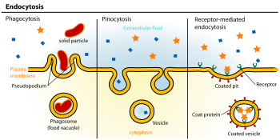
  - Exocytosis =
    - The reverse of endocytosis
    - Used to move waste or substances (proteins) from the interior of the cell to the outside environment
      - Example of exocytosis of proteins
        - Vesicle coming from ER
        - Vesicle entering the cis side of the Golgi apparatus
          - Cis face – receiving side of Golgi
          - Trans face – shipping side of Golgi
        - Cisternae move in a cis-to-trans direction
        - Vesicle leaves the trans side of the Golgi apparatus with modified contents
    - Examples:
          - Pancreas cells produce insulin & secrete it into the bloodstream (to help regulate blood glucose levels)
          - Neurotransmitters are released at the synapse in the nervous system


