Bio 9 - Unit 1: Data Analysis Practice #1 Name:

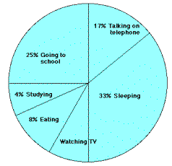
- Typical Teenager. Answer the questions below about the graph at the right that represents the typical day of a teenager.
  - What percent of the day is spent watching TV?
  - How many hours are spent sleeping?

  - What activity takes up the least amount of time?
  - What activity takes up a quarter of the day?
  - What two activities take up 50% of the day?

  - What two activities take up 25% of the day?

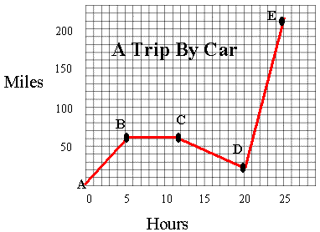
- Driving a Car. Answer the questions below about the graph at the right that represents miles traveled over time.
  - How many total miles did the car travel?
  - What was the average speed of the car for the trip?
  - Describe the motion of the car between hours 5 and 12.
  - What direction is represented by line CD?
  - How many miles were traveled in the first two hours of the trip?
  - Which line represents the fastest speed?
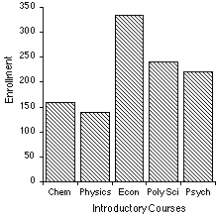
- Course Enrollment. The bar graph at the right represents the declared majors of freshmen enrolling at a university. Remember, you can have more than one major in college!
  - What is the total freshmen enrollment of the college?
  - What percent of the students are majoring in physics?
  - How many students are majoring in economics?
  - How many more students major in poly sci than in psych?
Declared Major

- Distance and Time. Graph the following data about distance over time. Remember to title your graph and label the axes!

Time (seconds) | Distance (meters)
0 | 0
1 | 2
2 | 8
3 | 18
4 | 32
5 | 50
6 | 72
7 | 98
8 | 128
9 | 162
10 | 200

- What is the independent variable?

- What is the dependent variable?

- What is the relationship between distance and time?

Bio 9 - Unit 1: Data Analysis Practice #2 Name:

- Clam Development. A clam farmer has been keeping records concerning the water temperature and the number of clams developing from fertilized eggs. The data is recorded below. Make a graph of the data.

Water  Temperature (⁰C) | Number of  Developing Clams
15 | 75
20 | 90
25 | 120
30 | 140
35 | 75
40 | 40
45 | 15
50 | 0

  - What is the independent variable?
  - What is the dependent variable?
  - What is the optimum temperature for clam development?

- Tree Rings. The thickness of annual tree rings indicate what type of environmental situation was occurring at the time of its development. A thin ring, usually indicates a rough period of development – lack of water, forest fires, or a major insect infestation. On the other hand, a thick ring indicates just the opposite. Make a line graph of the data. Use a different color or style of line for the two different sets of data that you will plot.

Age of Tree (years) | Average Thickness of the Annual Rings (cm)  Forest A | Average Thickness of the Annual Rings (cm)  Forest B
10 | 2.0 | 2.2
20 | 2.2 | 2.5
30 | 3.5 | 3.6
35 | 3.0 | 3.8
50 | 4.5 | 4.0
60 | 4.3 | 4.5

  - What is the independent variable?
  - What is the dependent variable?
  - What was the average thickness of the annual rings of 40 year old trees in Forest A?

  - Based on this data, what can you conclude about Forest A and Forest B?
- Hookworms. Hookworms live in the human intestine drinking the blood it sucks from the intestine wall. It is estimated that a single hookworm can drink 0.5 cm³ of blood per day. The chart below contains data on the number of hookworms and the amount of blood lost caused by that number of worms. In some cases, the data table is blank. Determine the number of worms or the amount of blood lost and complete the table.

Number of hookworms in the intestine | Amount of blood lost per day in cm³
24 | 12
45 | 40
80 | 44
88 | 25
63 | 6

