Unit 1: Scientific Method

- What is the Scientific Method?
  - A scientific way to solve a problem
  - All scientists use this.
- PHEOC
  - Problem
  - Hypothesis
  - Experiment
  - Observations
  - Conclusion
- Problem (Research) Question- What is wrong
  - Includes independent and dependent variable
- Hypothesis- Explanation for a question
  - Educated guess
  - If...then...because statement
- Experiment- The physical steps you take, numbered list of what was done
- Observation- Data within a data table
  - Numbers (measurements)
  - Descriptions of experiment
- Conclusion- If your hypothesis is correct or not and why
  - Talk about your data and how you can improve the experiment.
- How Do We Write a Hypothesis?
  - Three Requirements
    - If... then... because statement
    - Can be tested
    - Be specific!
      - Include units (Example: cm)
- How Do We Write a Hypothesis Examples:
  - Problem Question: Would eating chocolate cause pimples?
    - Incorrect: Chocolate may cause pimples.
    - Correct: If chocolate causes pimples, then people who eats lots of chocolate will get pimples, because chocolate leaves toxins in the intestinal tract.
  - Problem Question: Will salt in soil affect plant growth?
    - Incorrect: Salt in soil may affect plant growth.
    - Correct:________________________________________________________________________
  - Problem Question: Will plant growth be affected by the color of the light?
    - Incorrect: Plant growth may be affected by the color of light.
    - Correct:________________________________________________________________________
  - Problem Question: Does temperature affect bacteria growth?
    - Correct:________________________________________________________________________
  - Problem Question: Will Ultra violet light cause cancer?
    - Correct:________________________________________________________________________
  - Problem Question: Does temperature cause leaves to change color?
    - Correct:________________________________________________________________________
- What is the difference between hypothesis, theory & law?
  - Hypothesis - “_________________________________”; a ______________ explanation of phenomena.
  - Theory - a ___________________________ explanation of natural phenomena; has stood up to testing.
    - Example: Evolution
  - Law - a statement of what __________________________ under certain conditions.
    - Example: Gravity
- Variables
  - Control-______________________________________________________________________________
  - Independent Variable-___________________________________________________________________
    - You- CHANGE- it!
    - You can only have one independent variable!
    - You must include units.
    - X-axis on graph
  - Dependent Variable-____________________________________________________________________
    - You –MEASURE-it!
    - You can only have one dependent variable
    - You must include units
    - Y-axis on graph.
- Kinds of Data
  - Quantitative-__________________________________________________________________________
      - There were 7 blue birds after 3 months.
      - The plant grew 5.6cm over 9 days.
  - Qualitative =_________________________________________________________________
      - A Red and Yellow bird couple gave birth to all blue birds.
      - The solution turned from colorless to a blue color.
- SI = _________________________________________________
  - Base Units
    - Length = _______________________________________
    - Mass =_________________________________________
    - Volume =_______________________________________
    - Time = ________________________________________
- Observations: Graphing
  - Always need a _________________________________________________________________________
  - Logical scale on each axis that is labeled
  - Axes need a label with __________________________________
- Line Graph
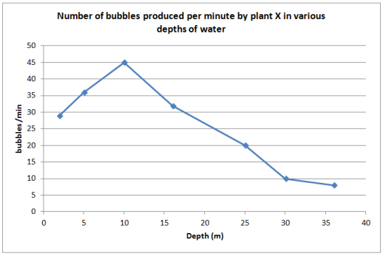
  - Used to ______________________________________________________________________________
  - Used when data is ________________________

- Bar Graph
  - Used to ______________________________________________________________________________
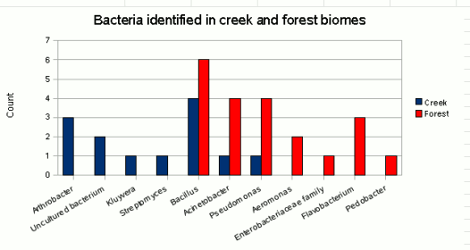
  - Can be used to show data is ____________________________________

- Experimental Procedure
  - _____________________________________________________________________________________
  - _____________________________________________________________________________________
  - Include all steps, including how to get and record the data.
- Conclusion
  - _____________________________________________________________________________________
  - To write your conclusion, give specific examples from your results (data) to fully answer the research question. Explain how the results support or negate your hypothesis.
  - Your conclusion should be fully supported by your actual data.

