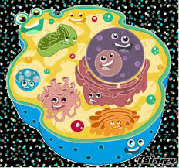  ORGANELLE | LOCATION | DESCRIPTION | 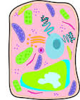  FUNCTION
Cell Wall | Plants only | Outer layer | Support & protection
Cell Membrane | Both, plant and animal | Plant- inside cell wall  Animal- outer layer
Nucleus |  | Large, round
Nuclear
Membrane

Cytoplasm

Smooth
Endoplasmic
Reticulum
Rough
Endoplasmic
Reticulum
Ribosome

Mitochondrion

Vacuole

Lysosome

Chloroplast

Nucleolus

Golgi
Apparatus

ORGANELLE | LOCATION | DESCRIPTION | FUNCTION
Centrioles

Centrosome

Microtubules

Peroxisomes

Amyloplast

***Draw a bacteria, an animal and plant cell below.

