Biology 9: Unit 2 Practice #5 Name: ______________________________ Block: ______
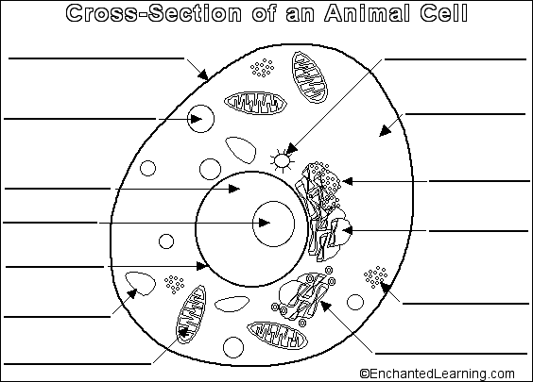
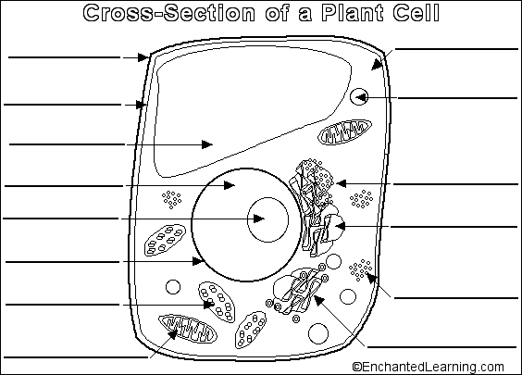
Directions: Label the organelles in the diagrams below of a plant and animal cell and give their function.

