Biology 9 – Unit 3: Data Analysis Practice #1 Name: _____________________________________
- Make two graphs with the following experiment information (ecosystem #1 and #2).
A greenhouse built in the Arizona desert in the USA, has been used to study different ecosystems. It is a closed system so measurements can be made under controlled conditions. The data shown below were collected over the course of one day in January 1996.
Ecosystem #1
Concentration of CO₂ (ppm) | Time (hours)
110 | 2
140 | 4
285 | 6
310 | 8
390 | 10
410 | 12
420 | 14
480 | 18
310 | 20
280 | 22
100 | 24
Ecosystem #2
Concentration of CO₂ (ppm) | Time (hours)
0 | 2
50 | 4
90 | 6
150 | 8
210 | 10
440 | 12
590 | 14
640 | 18
430 | 20
210 | 22
50 | 24
- Make a conclusion regarding the two graphs.
..........................................................................................................................................................
..........................................................................................................................................................
..........................................................................................................................................................
...........................................................................................................................................................
..........................................................................................................................................................
...........................................................................................................................................................
............................................................................................................................................................
............................................................................................................................................................
...........................................................................................................................................................
...........................................................................................................................................................
..........................................................................................................................................................
...........................................................................................................................................................
............................................................................................................................................................
............................................................................................................................................................
...........................................................................................................................................................
...........................................................................................................................................................
..........................................................................................................................................................
...........................................................................................................................................................
............................................................................................................................................................
............................................................................................................................................................
...........................................................................................................................................................

Biology 9 – Unit 3: Data Analysis Practice #2 Name: _____________________________________
1. The rate of photosynthesis in the marine seagrass, Zostera marina, was investigated under a range of pH conditions. After a period of darkness, the plants were illuminated at a constant light intensity at 15°C and the rate of photosynthesis was measured. Zostera marina can use both dissolved carbon dioxide (CO2) and hydrogen carbonate ions for photosynthesis. The rate of photosynthesis is plotted on the y-axis on the left. In addition, the concentration of carbon dioxide was measured for each pH investigated and is plotted on the y-axis on the right.
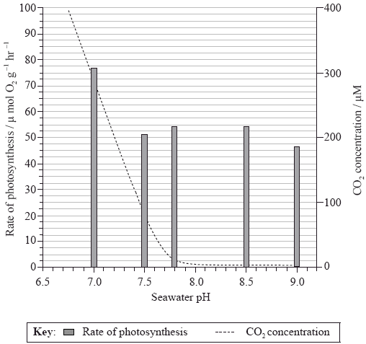
(a) State the carbon dioxide concentration at pH 7.2.
......................................................................................................................................
(1)
(b) Calculate the percentage decrease in the rate of photosynthesis from pH 7 to pH 7.5.
......................................................................................................................................
......................................................................................................................................
(1)
(c) Outline the relationship between pH and the rate of photosynthesis.
......................................................................................................................................
......................................................................................................................................
......................................................................................................................................
(2)

2. The effect of temperature on photosynthesis was studied in sweet orange (Citrus sinensis) using leaf discs. The production of oxygen was used to measure the rate of photosynthesis.
Gross photosynthesis refers to the sum of net photosynthesis and respiration. Net photosynthesis was calculated by subtracting the rate of respiration in the dark from gross photosynthesis.
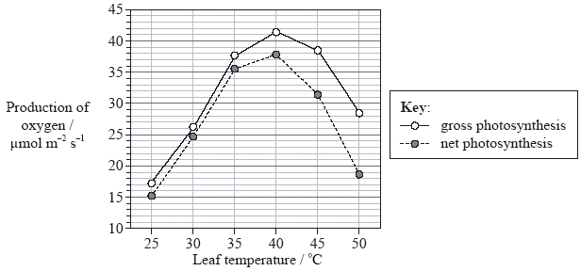
(a) Identify the optimum temperature for photosynthesis in this plant.
......................................................................................................................................
(1)
(b) Determine the difference between gross photosynthesis and net photosynthesis at 40°C and 50°C.
40°C: ..........................................................................................................................
50°C: ..........................................................................................................................
(2)
(c) Deduce what happens to the rate of respiration as the temperature increases between 40°C and 50°C.
......................................................................................................................................
(1)
(d) Compare the effect of temperature on photosynthesis with the effect of temperature on respiration in sweet orange.
...........................................................................................................................
...........................................................................................................................
...........................................................................................................................
...........................................................................................................................
...........................................................................................................................
(3)

