Name:_________________________ Block:____
Unit 3: Photosynthesis and Cell Respiration
- Chemical Energy
  - All ______________________molecules in food store chemical energy in their _____________________
  - _____________________________________________ are the most important energy sources
    - Energy is only available once the molecules are _________________________
- _________________________________ (ATP)
- Molecule that transfers energy from the breakdown of food to cell processes
- Function
    - ______________________________ molecules
    - Moving materials by __________________________________________
- Energy in ATP
- Energy is released when a ______________________________________ is removed from the molecule
- The bond holding the third phosphate is _______________________ and easily broken to form _______
- ATP in Food
- Food that we eat does not contain ATP that our cells can use
- The food must be ___________________________ and broken into smaller molecules.
- Different foods provide different amounts of _________________
- Photosynthesis
- Conversion of ________________ energy into ______________ energy (carbohydrates = sucrose and starch) inside the _________________
- Light-______________________ reaction (needs light) and light-__________________ reaction (doesn’t need light)
- Chlorophyll
- A green pigment molecule in the ______________________ that absorbs the ______________ energy
- Two types: ________________________________ and _______________________________
    - Absorb mainly red and blue light
- Rate of Photosynthesis
- Measured by production/release of ___________________ or uptake of _____________________ or increase of biomass
- Light- ______________________ Reaction
- Takes place within ____________________________ membrane
- ____________________________________________________ are needed
- Light- __________________________________ Reaction Process
- ________________________________ absorbs energy form sunlight.
- ___________________________ transferred along thylakoid membrane.
- ______________________ molecules broken down. ___________________released.
- Energy carried along thylakoid membrane transferred to ATP.

- Light- ______________________ Reaction
- Uses energy from the _________________________________ to make sugars(carbohydrates = glucose)
- Occur in the _____________________ of chloroplasts
- ___________________ is needed
- Light-Independent Reaction Process
- CO₂ is needed to build larger _____________________. Energy is needed from the light-dependent reaction.
- A molecule of simple sugar is formed, usually _________________________ (C₆H₁₂O₆), to store some of the energy that was ___________________________________________________.

- Photosynthesis Reaction

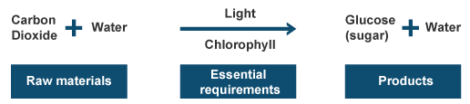

- Purpose
- Plants make their own _______________________.
    - Through _________________________
    - Inside the _______________________
- Eukaryotes break down molecules from food to _______________________________, or ATP
    - Through ________________________
    - Inside the ______________________
- Photosynthesis and Cellular Respiration
- ______________________________:
6CO₂ + 6H₂O + light energy -> C₆H₁₂O6 + 6O₂
- ______________________________:
C₆H₁₂O₆ + 60₂ -> 6H₂O + 6C0₂
- Energy form Food
- ________________________________ cannot directly make ATP from food.
- Foods are broken down into smaller molecules like ___________________________
- Three Main Steps
  - ____________________________- 2 ATP made
  - ____________________________- 2 ATP made
  - ____________________________________________________________- 32 ATP
- Glycolysis
  - Splits glucose into two three-carbon molecules and makes _______________________
  - Takes place in cell’s ______________________________
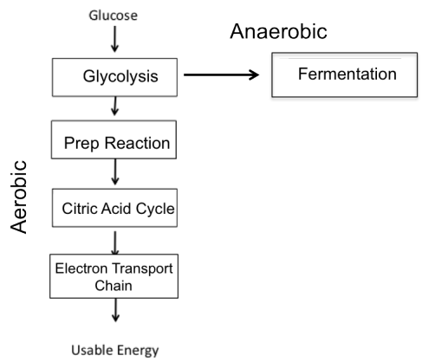
  - ________________________________: Doesn’t need Oxygen

- Is Oxygen Present?
  - Yes (Aerobic)? _____________________________________
  - No (Anaerobic)? ____________________________________
- Cellular Respiration
  - Releases ________________________ from sugars and other carbon-based molecules to make ATP when ________________________________
  - __________________________ process
-Needs ______________________________ to take place
  - Occurs in ________________________________
- _____________________ Cycle
  - 3-carbon molecule from glycolysis are broken down
  - Occurs in __________________________________________________
  - 2 ATPs are made, ___________________________ molecules transferred to Electron Transport Chain
- Electron Transport Chain
  - Energy-Carrying molecules from Krebs Cycle used to create ATP
  - _________________________________________
  - Occurs in __________________________________________ membrane
- Cellular Respiration Overview
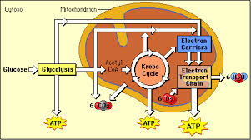

- ____________________ Respiration
  - ______________________________
  - Only 2 ATP (From Glycolysis)
  - Glycolysis and then _______________________________
  - Fermentations is just a way to get rid of the 3-carbon molecule
  - End products vary
  - Takes place in the _____________________
- ____________________ Fermentation
  - Used by bacteria and our ______________________!
  - Turn the 3-carbon molecule into lactic acid
  - _____________________________________
  - Makes cheese and Yogurt!!
  - Reason why our muscles get tired when we use them a long time
  - _________________________________- we owe our body oxygen to get rid of the lactic acid
- _______________________ Fermentation
  - Used by ___________________
  - Turns ________________________ into ethanol and Carbon
  - ____________________________
  - Used to make wine, beer and bread!
- Which would you rather do?
  - _______________________ makes 36 ATP
  - _______________________ makes ATP
  - As long as oxygen is around, you will always choose Aerobic. Anaerobic is only there so we organisms can survive if that are in an environment without oxygen ( or muscles can keep working when they run out of oxygen)

