Biology 9: Unit 4 -- Does Size Matter?

INTRODUCTION:
Cells are limited in how large they can be. This is because the surface area and volume ratio does not stay the same as their size increases. The large the cell becomes, the less surface area it has compared with its volume. It is therefore less efficient for a large cell to pass materials in and out through the membrane, and to move materials throughout the cell.
In this lab, you will make cube shaped models to represent cells. The dimension along one side will be doubled with each model. You will then calculate the surface area, volume, and the ratio between the two.

MATERIALS:
Scissors
Paper cube patterns
Tape or glue
Metric ruler

PROCEDURE:
- Form a group of 3.
- Each person in the group will be responsible for creating one cube.
  - Cut out the pattern. Fold and tape/glue each into a cube with the tabs to the inside.
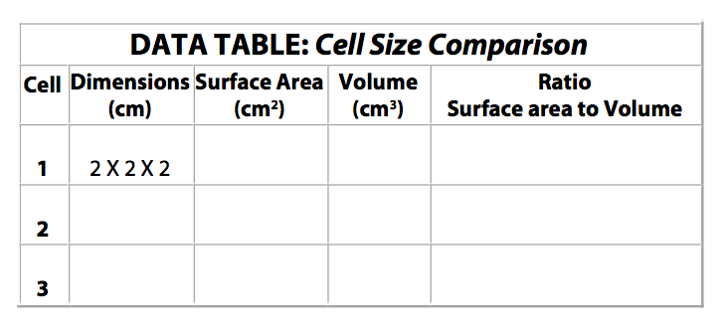
- The dimensions represent how long each side of the cube is. For example, if the length is 2 cm and the width is 2 cm and the height is 2 cm, the dimensions will be 2x2x2. Measure each cube and record the dimensions in the DATA TABLE (the first one for the smallest cube is done for you in the table).
- Fill out the rest of the dimensions using your measurements.

CALCULATIONS:
1. Calculate the total surface area for each cell model by the following formula:
Surface area = (length x width) x 6 sides
Record the surface areas in the DATA TABLE.
2. Calculate the volumes for each cell model by the following formula:
Volume = length X width X height
Record the volumes in the DATA TABLE.
3. Calculate the surface area-to-volume ratio for each cell model by the following formula:
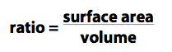
Record the ratio values in the DATA TABLE.

These ratios show how many times larger the surface area is as compared with the volume.

QUESTIONS:

- Which cell model has the largest surface area?

- Which cell model has the largest volume?

- Which increased more as the cell grew in size: cell volume or cell surface area?

- As the cell grew in size, what happened to the surface area to volume ratio? (how did the surface area of the cell compare to the volume? Remember: a ratio of ½ means that there is half the amount of surface area to volume, a ratio of 1 means that they are equal, a ratio of 2 means that there is twice the amount of surface area to volume)

To maintain life, and carry out cellular functions, materials must be able to move into and out of the cell as well as reach ALL parts of the cell including the CENTER. Also, material needs to be able to move within the cell.

- What might be an advantage of having a large surface area?

- As the cell grows larger in volume, what happens to the distance from the center of the cell to the cell membrane?

  - Why could this be a disadvantage for the cell?

- Which cell size (2 mm, 4 mm, or 6 mm) would have the best chance of survival in it’s environment? Why?

- What could a cell do to increase its surface area to volume ratio? (what shape would allow a cell to have a large surface area and small volume…draw your idea below and explain your drawing)

