Unit 5: DNA-RNA-Proteins
Biomolecules: Nucleic Acids and Proteins
- What is DNA?
- A complex biomolecule (nucleic acid) that stores all of the cellular information in form of a code to make proteins (Genetic code)
- Has complete instructions for making all proteins for ALL organisms
- Located in the nucleus and self-replicates
- DNA= Deoxyribonucleic Acid
-Genetic material for life and is universal to all life
- History of DNA Structure
- Scientists Watson & Crick developed a model of DNA structure
  - proposed that sugar-phosphate backbone on the outside and bases on the inside
  - DNA strands are complementary: they fit together and are opposite of each other
  - DNA is a double helix
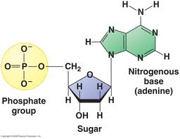
    - Two strands of DNA wind around each other like a twisted ladder
- Structure of DNA
- Small subunits that make up DNA are called nucleotides
- Each nucleotide has three parts:
  - A phosphate group
  - A simple sugar (carbohydrate) called deoxyribose
  - A nitrogen-containing base (nitrogenous base = A, T, C & G)
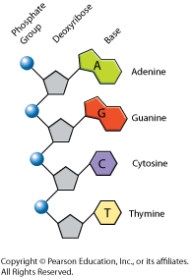
    - Phosphate group and deoxyribose make up backbone
- Nitrogen- Containing Bases
- Two types of nitrogenous bases
  - Purines = A & G (double ring structure)
  - Pyrimidines = T & C (single ring structure)
- 4 different nucleotides only differ in nitrogenous bases.
  - A= adenine
  - G= guanine
  - C=cytosine
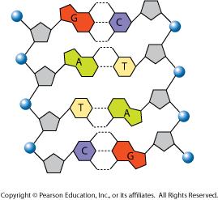
  - T=thymine
- Base Pairing Rules
- DNA molecule is Anti-parallel due to the Complementary bases
bonding in the middle
- Adenine (A) binds to Thymine (T)
    - Contains two hydrogen bonds between the bases
- Cytosine (C) binds to Guanine (G)
    - Contains three hydrogen bonds between the bases
- Explains Chargaff’s theory:
    - # of A = # of T
    - # of C = # of G
    - Example: 20 % of DNA is A
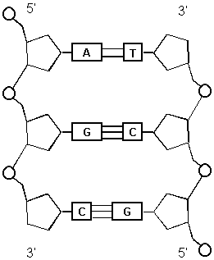
      - % of T = ?
      - % of U = ?
      - % of C = ?
- DNA Characteristics
- DNA is a double helix structure
- DNA model is called Anti-parallel
  - Each strand runs in opposite direction - five prime to three prime
(5’ to 3’)
- DNA has complementary base pairing
- Contains Covalent bonds and Hydrogen bonds
- Contains Nucleotides
  - Nitrogenous bases = C, G, T & A
    - Purines & Pyrimidines
  - Phosphate group
  - Deoxyribose sugar
- DNA Replication
- DNA self-replicates by Semi-Conservative
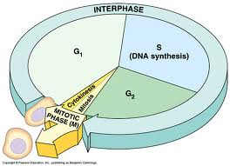
  - Produces two copies of DNA that each contains one strand of the original strands and one new strand
- Process where DNA is copied during the cell cycle (Interphase)
  - occurs during S phase of Interphase of the cell cycle
- DNA in Eukaryotes & Prokaryotes
  - Eukaryotes
      - Eukaryotic DNA is in the form of chromosomes
      - Replication occurs in the nucleus
      - Eukaryotes can begin self-replicating at any origin on the chromosome
      - Self-replicates in a five to three prime direction
  - Prokaryotes
      - Prokaryotic DNA is in the form of a ring
      - Replication occurs in the cytoplasm because the DNA is floating free in the cell
      - Has to begin self-replicating at the Origin of Replication
      - Self-replicates in a five to three prime direction
- The DNA Replication Process
  - Replication begins at the origin. (different places for eukaryotes & prokaryotes)
- Unzipping of the DNA molecule occurs by the action of the enzyme Helicase (this enzyme breaks the Hydrogen bonds between nitrogenous bases)
- Helicase creates a replication fork and provides the two original strands as templates to create two new strands by means of semi-conservative replication
- The DNA Replication Process Continued…
- The enzyme Primase adds a Primer at the replication fork to begin the replication process (A primer is made of RNA nucleotides that will attach to the DNA strand)
- DNA polymerase III is an enzyme that joins individual nucleotides to the growing DNA strand to produce a new strand of DNA that is complementary to the original DNA strand
    - New bases are added in a 5’ to 3’ and according to base pairing rules:
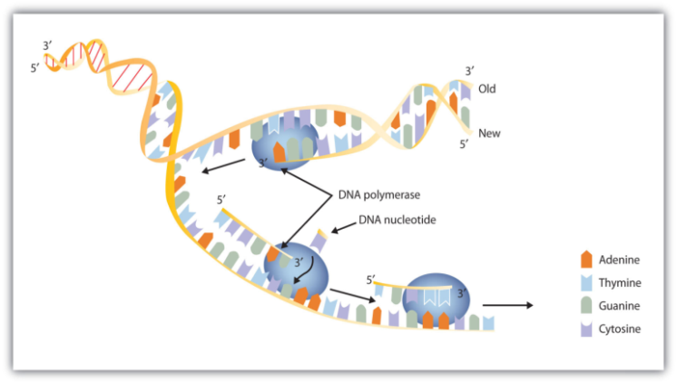
      - A with T
      - G with C

- The DNA Replication Process Continued…
- DNA polymerase I removes the primer and replaces it with DNA nucleotides to complete the self-replicating process
- The primer is made of RNA nucleotides so those can’t be left in the DNA molecule
- Two identical DNA molecules result. This is Semi-Conservative Replication (Produces two copies of DNA that each contains one strand of the original stands and one new strand)
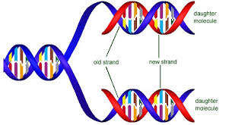

- The DNA Replication Process Continued…
- DNA is composed of two anti-parallel strands which are self-replicating at the same time in a 5’ to 3’ direction
  - Leading strand – being produced continuously and being replicated towards the replication fork
  - Lagging strand – being produced discontinuously and being replicated away from the fork

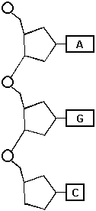
- What is RNA?
- RNA = Ribonucleic Acid
- A complex biomolecule (nucleic acid) that transfers information from
DNA to make proteins
- Single strand of nucleotides
- RNA is a complimentary copy of DNA used to make proteins.
- RNA Nucleotides
- Small subunits that make up RNA are called nucleotides
- Each nucleotide has three parts:
  - A phosphate group
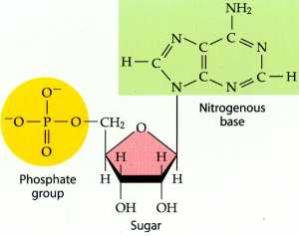
  - A simple sugar (carbohydrate) called ribose
  - A nitrogen-containing base (nitrogenous base = A, C , G & U)
    - U= uracil (Replaces T)
    - A= adenine
    - G= guanine
    - C=cytosine
      - Complementary base pairs → A-U & C-G
- Phosphate group and ribose make up backbone of RNA
- 3 Types of RNA
- mRNA → messenger RNA
  - Carries a copy of the DNA’s instructions (code) for the creation of proteins.
- rRNA → ribosomal RNA
  - Makes up ribosomes - structures where proteins are assembled.
- tRNA → transfer RNA
  - Carries amino acids to the ribosome and matches them to the coded mRNA message.

