Biology 9: Unit 5 - Building A DNA Model
The structure of DNA is similar to a spiral staircase. Notice that the “backbone” (or railing) is made of alternating sugars (deoxyribose) and phosphate molecules, and the “steps” are made of the base groups (Adenine, Thymine, Guanine and Cytosine). In this activity, you will build a DNA model, complementary mRNA model, and translate. You will be given a sheet of paper with various shapes; these shapes will represent different parts of the DNA molecule. The circles will represent the phosphate groups, the squares will represent the pyrimidine bases (Thymine and Cytosine), the rectangles will represent the purine bases (Adenine and Guanine), and the hexagons will represent the deoxyribose sugars.
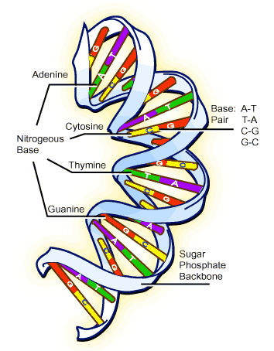
PROCEDURE: PART I
- Look at the attached sheet. In the center of the deoxyribose molecules (pentagon shape) write the letter D (for Deoxyribose sugar). In the center of the phosphate molecule (circle shape) write the letter P (for phosphate groups). On each pyrimidine base (square) write a different letter, either T or C. On each purine base (rectangle) write a different letter, either A or G. (It doesn’t matter how many of each base you have as long as there are 9 total). Your DNA strand will be only 9 nucleotides long!

- Color the deoxyribose sugars and the phosphate groups. Choose one different color for both the deoxyribose molecules and the phosphate groups. For example, all of the deoxyribose molecules could be green, and all the phosphate groups blue.

- Next color the bases. Designate each base a different color. Once ALL the pieces are colored, cut them out.

- Lay out the backbone towards the left side of your paper (alternating P and D molecules). Draw lines to show the covalent bonds between the sugar and phosphate molecules. Be sure to leave space for the bases and hydrogen bonds in the middle. (Hint: Make sure the bonds are in the correct location on the Deoxyribose molecule). Label this strand Coding Strand.

- Lay out the nitrogenous bases; remember you will be drawing the complimentary DNA strand (Template Strand). Make sure the bonds attached to the bases are the correct location on the Deoxyribose molecule. (Remember to label this strand the Coding Strand)

- Once you have your DNA laid out in the correct order, and THEN glue all the pieces to the paper to construct your DNA strand indicating the correct number of hydrogen bonds for the complimentary DNA strand.

- Replication: Using the sequence of DNA bases you have (Coding Strand), determine the complementary DNA strand or Template DNA strand by looking at the Coding Strand DNA strand AND drawing the replicated complimentary strand. Label this strand Template.

PROCEDURE: PART II

- Transcription: Using the sequence of DNA bases you have, determine the complementary mRNA strand by looking at the Template DNA strand. Draw your complementary mRNA stand next to your DNA molecule. Be sure to include the Phosphate group, Ribose sugar, and complimentary nitrogenous bases.

- Translation: Using the chart below, determine which Amino Acids you have based on the complimentary RNA strand. Remember that there may be more than one codon for each amino acid. If there are multiple options, choose one.
