Unit 5: DNA-RNA-Proteins
Biomolecules: Nucleic Acids and Proteins

- Transcription
- Formation of a mRNA strand which is complementary to a DNA strand
- Making mRNA from DNA in a 5’ to 3’ direction
  - Inside the nucleus of a Eukaryotic cell
  - Inside the cytoplasm of a Prokaryotic cell
- Transcription using the enzyme RNA polymerase
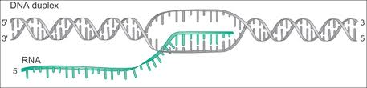

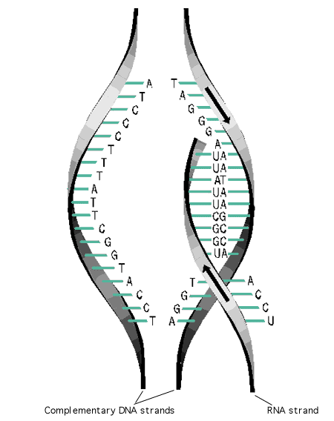
- Transcription Process
- RNA polymerase is an enzyme that separates the two DNA strands and combines to a portion of DNA that code for a specific protein.
  - Uses only one side of DNA to create a single strand of RNA
  - Uses only DNA as a template to lay RNA nucleotides in a specific order according to the DNA code

- Transcription Process Continued…
- When the DNA opens a transcription bubble occurs exposing the DNA nucleotides
- New bases are added to a growing mRNA strand in a 5’ to 3’ direction according to the complementary base pairing rules:
DNA = A T T C G C A T T
RNA = U A A G C G U A A
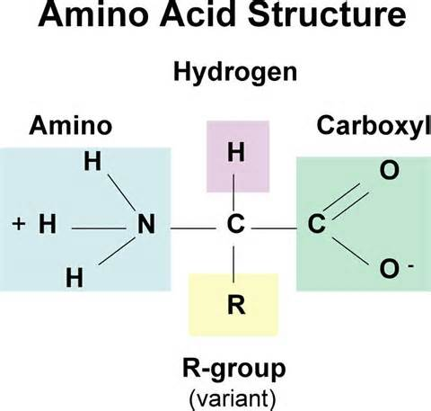
- A sequence of DNA nucleotides (terminator) will end the process of transcription and cause RNA polymerase and the mRNA strand to detach

- Amino Acids
- Basic building blocks of proteins
- There are 20 common amino acids
- Amino acids are connected by peptide bonds
- A chain of amino acids is called a polypeptide chain
- The creation of the polypeptide chain (protein) occurs in ribosomes
  - Free Ribosomes – create proteins for the cell
  - Bounded Ribosomes – create proteins to be shipped out of the cell
- Codon & Anticodon
- Every 3 nitrogenous bases on the mRNA codes for 1 amino acid. This is called a codon.
- tRNA carries the amino acids to the ribosome and matches them to the mRNA by having an anticodon
  - Anticodon is a set of three nucleotides on tRNA that is complementary to a mRNA codon
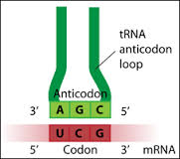
  - Example: Codon GGG pairs with Anticodon CCC
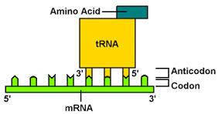

- Translation
- Process that converts or translates the information in a sequence of nitrogenous on the mRNA into a chain of amino acids to create a protein
- Translation occurs in a 5’ to 3’ direction
- The chain of amino acids is called a polypeptide chain
- The polypeptide chain codes for a protein from a gene on the DNA molecule

- Translation Process
- Translation begins at the start codon on the mRNA. The start codon is always AUG
- Delivers the first amino acid to the ribosome to begin to produce the polypeptide chain
- tRNA contains an anticodon that binds to the mRNA’s codon and carries one kind of amino acid.
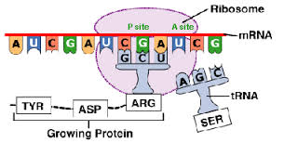

- Translation Process Continued…
- The elongation of the polypeptide chain occurs when the next tRNA brings another amino acid to the ribosome
- The polypeptide chains continue to grow until a stop codon appears on the mRNA
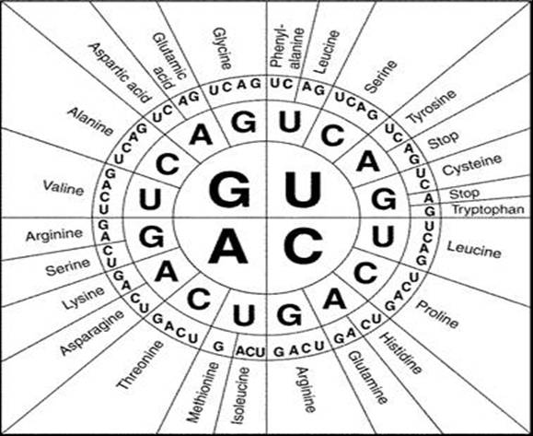
- The tRNA brings the corresponding amino acid to stop the process of translation. Now the newly formed polypeptide (protein) is then released

- Determining Protein Sequence

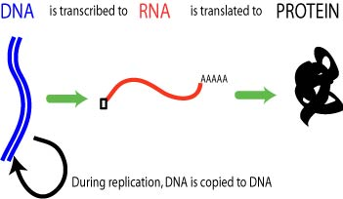

- The Central Dogma
- DNA→ mRNA→ Protein
- The creation of mRNA from DNA is called Transcription
- The creation of a protein from mRNA is called Translation

- Comparing DNA and RNA
 | DNA | RNA
Type of Sugar
Number of Strands
Nitrogenous Bases
Location in Cell

- Mutations
- A Mutation is a permanent change of the nucleotide sequence of the genome of an organism
  - Genome is the complete DNA sequence of an organism
- Typically happens during replication if it affects a single gene
- If a mutation is not fixed, if may permanently change an organism’s DNA
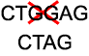
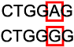
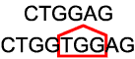

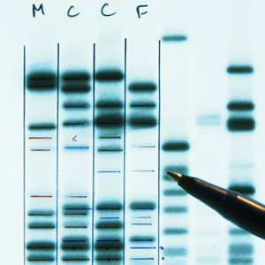
- Effects of Mutations
- Genetic diseases
- Cancer
- New genetic traits
- No harm at all

- Manipulating DNA
- How can we manipulate DNA?
  - Literally cut it into pieces.
  - Done through proteins called restriction enzymes
- What can it be used for?
  - Paternity testing
  - Criminal Investigation
  - Genetic Engineering
  - Cloning

- Paternity and Criminal Investigations
- Cut up fragments of DNA are put into a gel electrophoresis
- Depending on how big the segment of DNA, the further down the gel a fragment of DNA will move
- Then compare one person’s DNA to another person’s to see if they’re related

- Genetic Engineering
- Cut up fragments of DNA with specific genes can be added to DNA of a fertilized egg
  - This can give rise to organisms with new traits
  - Example: Mice that can glow

- Cloning
- Theoretically, any organism can be cloned to make a genetically identical organism
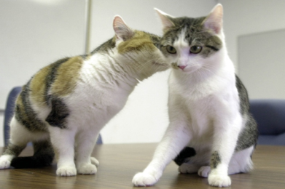
*These two cats are clones but, they look different. This is because different genes on the same DNA can be activated by the different environments the organism grew up in

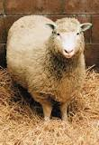

- Dolly the Sheep (1996)
- She was the first mammal to be cloned from an adult cell

