Biology 9 -- Unit 6: Inheritance
I. Genetics
- Genetics
-The branch of biology that studies heredity
- Heredity
-The passing on of characteristics from parents to offspring through GAMETES (sex cells created in meiosis)
- Traits
-Characteristics that are inherited from the chromosomes you receive from each parent. (Review Meiosis)
II. Meiosis and Genetic Variety
- Meiosis will result in the production of sex cells (gametes) which show an increase in genetic variety because of:
- Crossing over during prophase I
-Crossing over is when non-sister chromatids exchange genetic material
- Random orientation of chromosomes during metaphase I
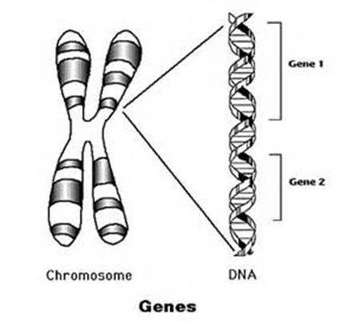
-Random orientation is when the homologous chromosomes line up on the metaphase plate in a random order
III. Genes in DNA
- Gene
-The heritable factor that codes for a polypeptide chain or for an RNA chain that has a function in the organism
- Genome
-The whole genetic information of an organism

IV. Mendel Genetics
- Gregor Mendel
-19th century Austrian Christian Monk
-His research is the basis for our modern day notion of heredity.
-Worked with pea plants to see how different traits were passed from generation to -generation.
V. Mendel’s Monohybrid Crosses
- Monohybrid Cross = 1 trait that differs in parents
-Mendel created hybrids of pea plants from pure breeds
- A Pure breed is an organism with no genetic variety
-Mendel used pea plant height to determine how traits were passed on
-He crossed one pure breed tall parent and one pure breed short parent
-Each offspring had a combination of traits from each parents.
VI. Mendel’s Results
- P1 (parents) short pea plant X tall pea plant
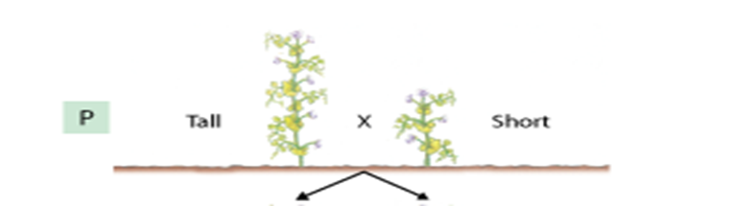
- F1(generation 1 = all tall)
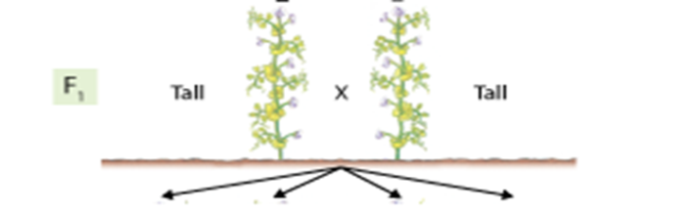
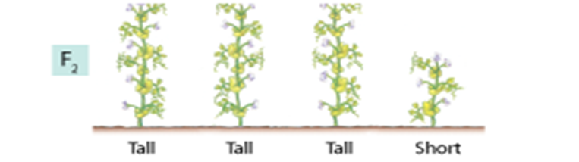
- F2 (generation 2 = 3 tall: 1 short)

VI. Mendel’s Law of Independent Assortment
- The Law of Independent Assortment states that every individual has 2 alleles for each gene (trait)
-During Meiosis, the chromosomes which carry the alleles for a trait will be randomly distributed to the newly produced gametes.
-This means that every gamete produced will be genetically unique from the other gametes.
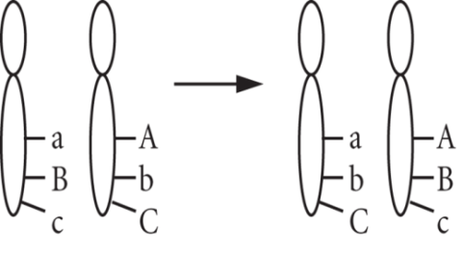
VII. What are alleles
- Alleles are found directly on chromosomes.
- Alleles are different forms (types) of the same gene (trait)
-Ex. Gene for height= H/h
- You have two alleles for each trait
-1 from your mother and 1 from your father
- 3 different allele combinations can be possible:
-HH / hh / Hh
VIII. Examples of Alleles
- Dominant
-Trait that shows up and will hide the recessive allele
-Examples: HH & Hh = Tall
- Recessive
-Trait that can be hidden by the dominant allele
-Must have two recessive allele to show recessive trait
-Examples: hh = short
- Phenotype- What the organism looks like
- Genotype- The allele combination an organism contains. [HH or Hh or hh]
IX. Combination of Alleles
- Homozygous Dominant
-Having 2 dominant alleles
-Example: HH
- Heterozygous
-Having 1 dominant allele and 1 recessive allele
-Example: Hh
- Homozygous Recessive
-Having 2 recessive alleles
-Example: hh
X. Monohybrid Punnett square
- Monohybrid Punnett Square Set Up:
-Both parents are heterozygous for being tall
-Monohybrid cross is Hh x Hh
- Genotype: HH = 1/4 or 25%, Hh = 2/4 or 50% & hh = 1/4 or 25%
- Phenotype: Tall = 3/4 or 75% and short 1/4 or 25%
Possible Alleles individual Sperm cells have from Father

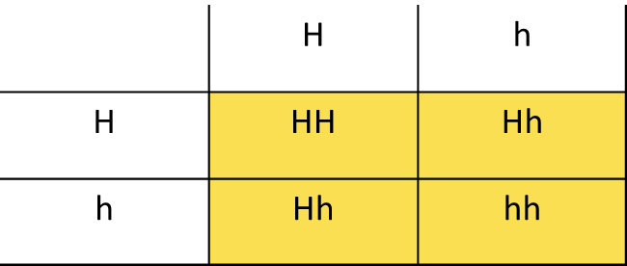
Possible Alleles individual Egg cells have from Mother
Possible offspring and the Alleles each offspring could receive

