**Unit 6: Inheritance**

**XII. Dihybrid Cross**

Dihybrid Crosses- (Creates more varied hybrids)

* 2 traits that differ between parents
* Example Traits: Height and shape
* Each trait gets one letter=

-Height= H is tall & h is short

-Shape = R is round & r is wrinkled

-One parent is heterozygous tall and heterozygous round (Hh and Rr)

-One parent is homozygous short and homozygous wrinkled (hh and rr)

**XIII. Dihybrid Punnett Square**

Dihybrid Punnett Square Set Up:

* One parent is heterozygous tall & heterozygous round = **HhRr**
* One parent is homozygous short & homozygous wrinkled = **hhrr**
* The cross is: **HhRr** x **hhrr**
* NOTICE: I put all possible combinations the father and mother could provide to the offspring, and each top box gets one of each trait!

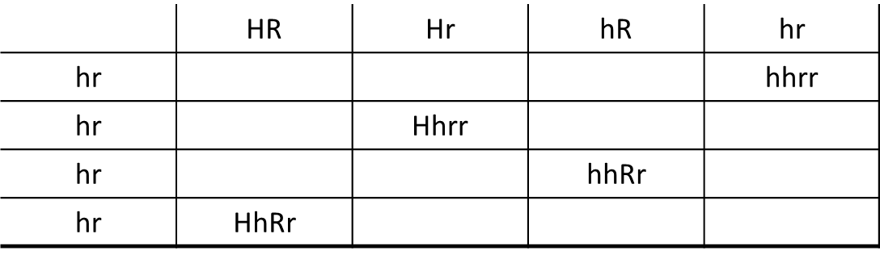

**XIV. Pedigree**

* A graphic representation of genetic inheritance
* Different symbols represent different traits and organisms

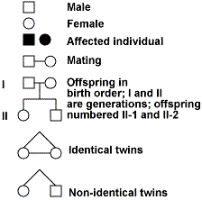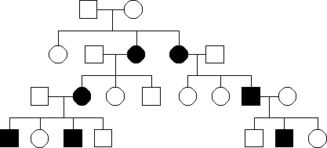

**XV. Recessive Pedigree**

Simple Recessive heredity

* Recessive allele must be inherited from BOTH parents for trait to show
* Examples: Cystic fibrosis and Tay- Sachs
* Determine Genotypes and Phenotypes for Generation I, II and III

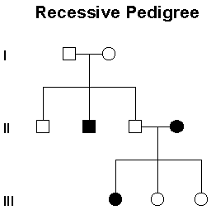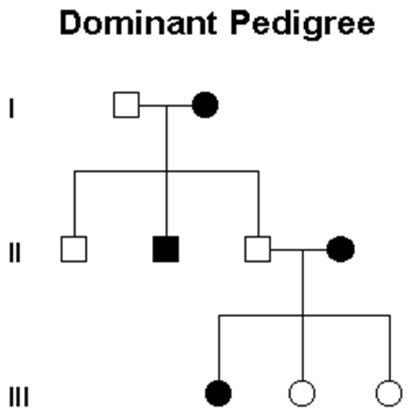

**XVI. Dominant Pedigree**

Simple Dominant heredity

* One single dominant allele can be inherited from one parent to show dominant trait
* Examples: Widows peak and Huntington's disease
* Genotypes and Phenotypes for Generation I, II and III

**XVII. Codominance**

Codominance- when both alleles are expressed equally to create a NEW phenotype

* Red flower CR CR crossed with a White flower CW CW
* Example: Flower color and Blood type
* Determine the Genotype and Phenotype for the offspring below

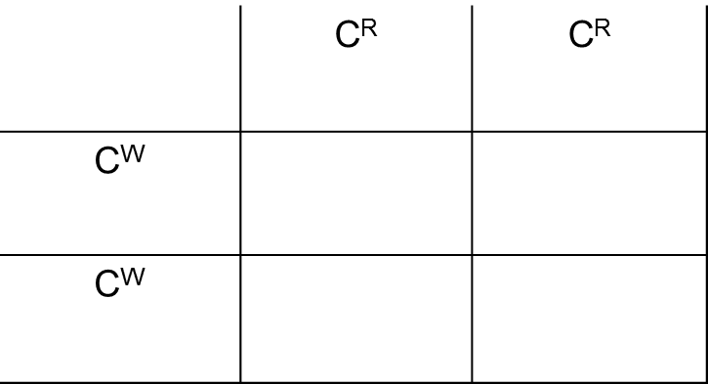

**XVIII. Multiple Alleles**

* Blood Types are Multiple alleles & Codominance example
* Blood type is determined by three different alleles IA, IB, and i.
* These three alleles give rise to the ABO blood types in humans
* Both A and B result in the creation of specific proteins that appear on the surface of the Red Blood Cell (RBC)

-These proteins on the RBC are ID passes to let the body know that these blood cells belong to that body

*-i* is an allele that does not produce proteins on the surface of the RBC.

**XIX. Blood Types and RBC’s**

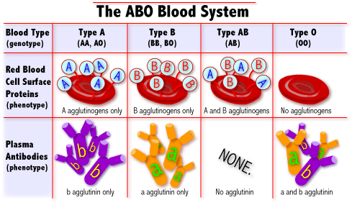

**XX. Blood Type Alleles**

* Type A Blood alleles:

**-IA IA** OR **IA i**

* Type B Blood alleles:

**-IB IB** OR **IB i**

* Type AB Blood alleles:

**-IA IB**

* Type O Blood alleles:

**-i i**

**XXI. Blood Type Monohybrid Cross**

|  |  |  |
| --- | --- | --- |
|  | **IA** | **i** |
| **IB** |  |  |
| **I** |  |  |

* Example: The Father has type A blood and the mother has type B blood. What are the potential blood types of the children

-Father is heterozygous for Type A blood= **IA i**

-Mother is heterozygous for Type B blood= **IB i**

-The cross i = **IA i** x **IB I**

* Determine the Genotype of the offspring:
* Determine the Phenotype of the offspring:

**XXII. Polygenic Inheritance**

* Involves two or more genes influencing the expression of one trait.
* [Example: Skin color](http://www.youtube.com/watch?feature=player_embedded&v=cYZyvxpsCjQ)

-Determined by alleles at several different genes (this gene creates a protein called melanin)

-We have packets of melanin in our skin that is the color brown.

-Some of us have more melanin or less.

-The more melanin you have, the darker skin you have.

**XXIII. Types of Chromosomes**

* Autosomes – contain genes not associated with sex

-In humans there are 22 pairs of autosomal chromosomes

* Sex chromosomes – directly control sexual traits.

-In humans there is 1 pair of sex chromosomes

-Females have two X chromosomes

-Males have one X and one Y chromosome

**XXIV. Sex-linked Inheritance**

* Sex Chromosomes (The 23rd chromosomes) determine sex of offspring
* There are certain traits controlled by genes located on sex chromosomes
* Sex-linked traits deal with only two chromosomes: X and Y
* Females are X X and Males are X Y

-Ex: Disorders on the X chromosome

-Red-green color blindness- recessive allele

-Male pattern baldness

**XXV. How Sex-linked Traits are Passed on**

* If trait is a X-linked trait the mother and father can both pass the trait on
* If the trait is a Y-linked trait only the father can pass it on
* The trait in question gets written as a superscript:

|  |  |  |
| --- | --- | --- |
|  |  |  |
|  |  |  |
|  |  |  |

-Example: X-linked recessive trait

-Female without the trait = XH XH ORXH Xh

-Female with the trait = Xh Xh

-Male without the trait = XH Y

-Male with the trait =Xh Y

**XXVI. Sex-linked Punnett Square Set Up**

* Example of a Sex-linked trait is Hemophilia
* Hemophilia is a X-linked recessive disease
* 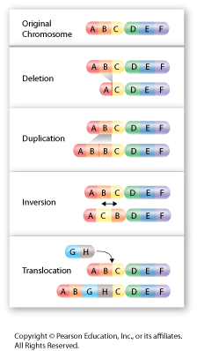Example: The father does not have hemophilia but the mother is a carrier of the disease.

-Father is **XHY** and the Mother is **XHXh**

-The cross is= **XHY** x **XHXh**

-Determine the Genotype of the offspring:

-Determine the Phenotype of the offspring:

**XXVII. Mutations**

* Any random change in the DNA base sequence
* This could happen due to:

-Deletion of bases

-Duplicating bases

**-**Point Mutation- Certain bases changing places

-New bases being inserted where they do not belong.

* Mutations can result in:

-Genetic diseases

-Cancer

-New genetic traits

-No harm at all

**XXVIII. Karyotypes**

* Karyotype- is the number and appearance of chromosomes in the nucleus of a eukaryotic cell
* Karyogram - a diagram or photograph of the chromosomes of a cell, arranged in homologous pairs and in a numbered sequence (chromosomes are arranged in order according to size, shape and centromere position)

-Used to check for chromosomal number abnormalities

**XXIX. Genetic Disorders**

|  |  |  |
| --- | --- | --- |
| **Disorder** | **Mutation** | **Chromosome** |
| Color Blindness | Point | X |
| Cystic Fibrosis | Point | 7 |
| Down Syndrome | Extra Chromosome 21 | 21 |
| Hemophilia | Point | X |
| Sickle-cell Disease | Point | 11 |

**XXX. Gene Transfer**

Gene Transfer – A technique of taking a gene out of one organism and placing it in another organism.

* This is possible because DNA is universal
* The same amino acids are coded for by the same codons on the mRNA.
* Example: Placing the gene that codes for insulin in bacteria cells in order to produce insulin for

diabetics

**XXXI. Materials Used for Gene Transfer**

* Plasmids - small circles of DNA in bacteria or prokaryotic cell
* Host cell – bacteria or yeast (prokaryotic cell with plasmids)
* Restriction enzymes- a protein that finds and recognize a specific sequence of base pairs along the DNA molecule
* 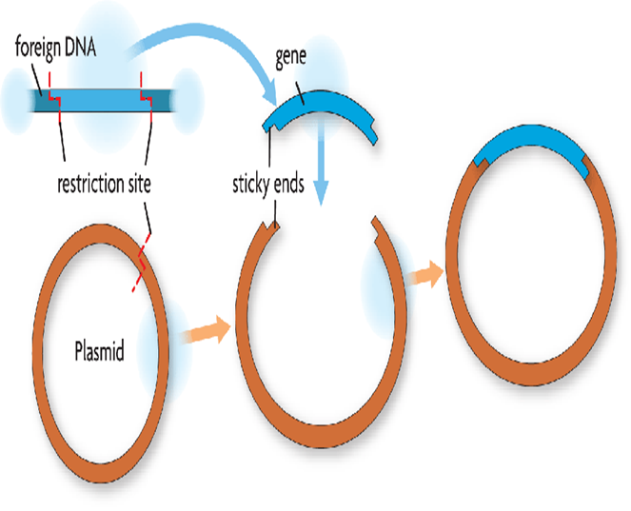DNA ligase – connects or glues sequences together

**XXXII. Gene Transfer Process**

* A gene is selected to be transferred into an organism
* Restriction Enzymesare used to cut both the gene of interest from the DNA and the plasmid in the prokaryotic cell
* The gene is inserted into plasmid using Ligase
* The plasmid with the new gene is inserted into the bacteria (host cell)
* This results in the bacteria making many copies of the gene
* The Isolated gene is then passed into the genome of the desired organisms using an enzyme

**XXXIII. GMO’s**

GMO is a Genetically Modified Organism- An organism that has had an artificial genetic change due to gene transfer.

* Genes in certain plants may be removed and replaced with genes that are more desirable.
* Genetically modified food has helped farmers to grow foods in various otherwise unsuitable conditions
* Example: 85% of corn has been modified so that they are resistant to the herbicide glyphosate,

which is used to kill weeds