Name:_______________________________________Block:___________

Biology 9:Unit 6: Genetics
Pedigree

1. The trait represented by the colored circles and squares below is inherited as a dominant allele. This is not a sex-linked trait. Shaded individuals show the dominant trait.
A= Dominant trait
a= Recessive trait
a) What is the probable genotype of each individual? (Label next to individual)
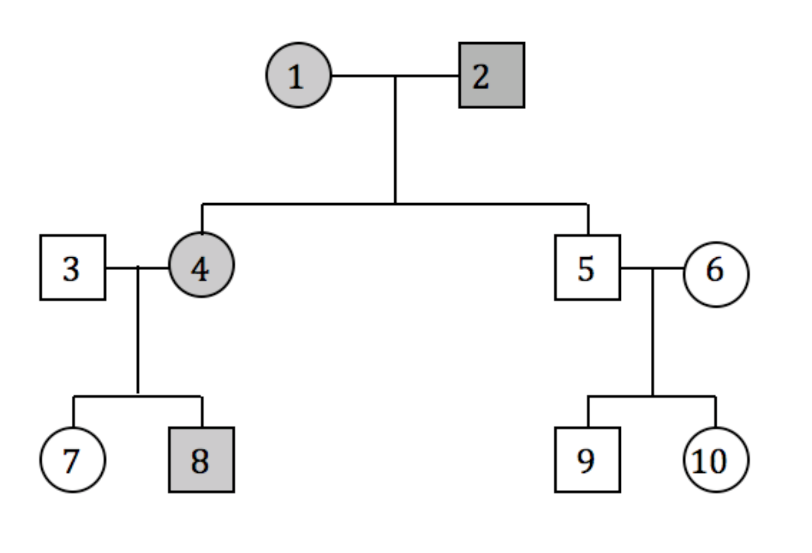
b) Are there any homozygous dominant individuals in the pedigree? How do you know?

c) What is the probability of the trait appearing in offspring if 7 should marry 9?

d) What is the probability of the dominant trait appearing in offspring if 8 should marry 10?

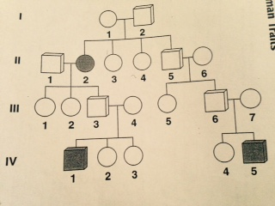
2.
a) Suppose that the pedigree shown above is for a trait caused by a recessive allele. Is it possible to infer from the pedigree whether or not I-1 and I-2 are carriers of the allele? Explain.

b) What can be inferred about the genotype of II-5 based on that person’s descendants?

c) Is II-1 a carrier of the recessive allele? Explain?

d) Are II-3 and II-4 carriers of the recessive gene? Explain?

e) Why must III-4 and III-7 be heterozygous?

f) Can you infer from the pedigree whether the pattern of inheritance is autosomal or sex linked?

